Climate Change and the Iron Age

Abstract
The climate in Britain got colder and wetter in the first quarter of the first millennium BC. The evidence for the change in climate is reviewed and the conclusion is that the growing season was shortened by five weeks and there was an increase in stormy weather. Iron Age farmers reacted by switching from arable to pastoral farming. The downs of central southern England were converted to sheep farming and there was an increase in dairying. The role of pits and four post structures is discussed. These have been thought of as grain stores but in the new agricultural regime little grain was produced so alternative uses have been suggested. Valley bottoms got much wetter in the Iron Age so it would have been necessary to limit lowland grazing and this is a possible reason for the introduction of common land. This suggestion is examined in some detail and some areas where common land is linked to hillforts are discussed. Common land and hillforts in a study area between Swindon and Oxford are plotted in ArcGIS and the NEAR function is used to determine if hillforts and common land are closer that would be expected if the relationship were random. The conclusions are that there are some areas where common land is associated with Iron Age hillforts and that the association between them is closer than would be expected if their distributions were totally random. This evidence strengthens case for some common land surviving from prehistory into the modern era. Another area of Britain (Dorset) is examined to see if conclusions from the study area can be extrapolated to other areas but further work is required to come to definite conclusions.

Contents
List of Figures 5
Chapter 1 Introduction 6
Literature Review 6
Chapter 2 Evidence for Climate Change 8
Chapter 3 The Late Bronze Age to Iron Age transition, Evidence for the
Significant Changes 11 Metalwork 11
Treatment of the Dead 11
Agriculture 12
Ceramics 12
Hillfort Building 12
Ridgeway Hillforts 13
Pits 14
Chapter 4 Impact of Climate Change on Iron Age Farmers 15
Evidence for Wetter Lowland Conditions 15
Agriculture on the Downs 16
Arable Agriculture 17
The Increase in Dairying 19
Storage of Food Through the Winter 22
Chapter 5 Examples of how specific hillforts interacted with the landscape 24
Hillforts of the Ridgeway 24
Purton Parish 28
Newbury Hillforts 29
Chapter 6 Discussion 37
Chapter 7 Dorset 40
Chapter 8 Summary and Conclusions 42
Future Research 43
Community Engagement 44
Appendices 45
Appendix 1 Hillforts of the Study Area 45
Appendix 2 Commons of the Study Area 46
Appendix 3 Hillforts of Dorset 48
Bibliography 49

List of Figures
Figure 1 Whole year temperatures in Britain 9
Figure 2 Dates of Ridgeway hillforts 14
Figure 3 Terraces on the hillside nr Battlesbury 17
Figure 4 Terraces near Rybury Camp 18
Figure 5 Terraces near Martinsell Hill and Giants Grave 18
Figure 6 Sheep being dug out of snow 21
Figure 7 Caer Caradog hillfort in snow 21
Figure 8 Layout of Ridgeway parishes 24
Figure 9 Liddington Castle 26
Figure 10 Uffinton and Kingston Lisle parishes 27
Figure 11 Purton parish 28
Figure 12 Ringsbury Camp, access to common land 29
Figure 13 Borough Hill and Boxford Common, linked by footpath and linear
Feature 30
Figure 14 Linear feature on LIDAR 31
Figure 15 Bussocks Camp, Snelsmore Common and Snelsmore East Common 32
Figure 16 Oareborough Hill and Oareborough Common 33
Figure 17 Linear feature running parallel to Oareborough Lane 34
Figure 18 The study area and surroundings 35
Figure 19 Hillforts, commons and parishes in the study area 35
Figure 20 Distance of hillforts to nearest common land 36
Figure 21 Dungeon Hill hillfort, parish boundary and common land 41

Chapter 1
Introduction
The transition from Bronze Age to Iron Age in Britain happened around 800 BC (Needham 2007). Some put the start of the Iron Age a bit later, around 750 BC, and this is the date that Cunliffe (2005 31,32) uses for the start of the Iron Age in Europe. Cunliffe also breaks down the Iron Age into five different phases, the Earliest Iron Age 750 – 600 BC, Earlier Iron Age 600 – 400 BC, Middle Iron Age 400 – 100 BC, Late Iron Age 100 BC – 0) and Latest Iron Age (0 – 43 AD) and this is the terminology which will be used in this dissertation. One of the problems assigning dates to Late Bronze Age, Earliest and Earlier Iron Age contexts is the lack of reliable radiocarbon dates. From around 800 BC to 500 BC there is a wiggle in the calibration curve, so dates obtained are very imprecise (Cunliffe 1984 195-198).
There were a number of changes that characterised the change from Bronze Age to Iron Age. During the Bronze Age, bronze was more than just a metal used for making tools, weapons and decorative items. Bronze items had a value as tradeable commodities and were a way of accumulating and demonstrating wealth in what was known as a prestige goods economy (Cunliffe 2005 586). Something changed in the Late Bronze Age and many bronze items were deposited in hoards and were not immediately replaced with iron. At the same time as iron started to be used there were changes to availability and design of ceramic items, there were changes to the way the dead were treated, changes to agriculture, and hillforts proliferated.
It is a widely held view that the climate deteriorated at the start of the Iron Age, becoming colder and wetter (eg Lamb 1981). It also appears that the climate started improving around 400 – 300 BC, the start of the Middle Iron Age. In other words, the climate deterioration coincided with the Earliest and Earlier Iron Ages. There are several questions I want to answer in this dissertation:
  - What is the evidence for climate change in the Late Bronze Age/Iron Age period?
  - What impact would climate change have had on the Earliest Iron Age farmers?
  - What did the Earliest Iron Age farmers do to ameliorate the impact of the deteriorating climate?
This dissertation is concentrating on the Earliest Iron Age and Earlier Iron Age (750-400 BC) when the climate was at its coldest and wettest.
Literature Review
The obvious place to start is Iron Age Communities in Britain by Barry Cunliffe. This encyclopaedic work, published in 2005, reviews all aspects of Iron Age life and its 700 pages cover all regions of Britain, so this is frequently referenced in the text of the dissertation. Almost as important for this dissertation was ‘The Earlier Iron Age in Britain and the Near Continent’, a volume edited by Haselgrove and Pope , published a few years later in 2007. This covers the Late Bronze Age to Iron Age transition and there are several papers on agricultural practice. For evidence of climate change my starting point was ‘The Environment in British Prehistory’ edited by Simmons and Tooley, and ‘The Environment of Man’ a BAR publication edited by Jones and Dimbleby. Both these books on the environment are relatively old, so much of the evidence for climate change comes from papers published in Science, The Journal of Quaternary Science and similar journals. Information about agricultural practices initially came from ‘The Farming of Prehistoric Britain’ by Fowler, but again this is fairly old (1983) and information was supplemented by more up to date papers. Information on hillforts was obtained mainly from ‘Beacons in the Landscape’ by Brown and ‘Iron Age Hillforts in Britain and Beyond’ by Harding.
Most of the publications mentioned acknowledge that the climate changed around the time of the Late Bronze Age to Iron Age transition but do not acknowledge the severity of the change or the impact that it must have had. This dissertation attempts to address that void.

Chapter 2
Evidence for Climate Change
Peat bogs are an ideal environment for measuring historic (and prehistoric) precipitation. When peat bogs are wet, they grow rapidly and when they are dry they grow more slowly. Peat bogs that have experienced changes in precipitation are stratified, with different types of peat in different layers (Turner 1981 252), and it is possible to radiocarbon date the different strata and determine the wetness of the bog at the time. Turner (1965) used the growth rate of Tregaron bog in West Wales to determine that, in the period 750 to 400 BC, there was extraordinary and unmatched wetness in that bog. Since then, there have been many studies of peat bogs across North-West Europe.
Although some work from Sweden (Turner 1981 253-255) had appeared to show that there were variations across a single bog and local conditions were more important than climate, Dickinson (1975) came to the opposite conclusion when studying a bog in the Lake District. There, different areas of the bog changed at the same time. This finding was replicated by studies of five Danish bogs (Turner 1981 256). The different layers of each bog developed at the same time, indicating that it was climate that was causing the changes, not local conditions. Furthermore, the date of this climate change was confirmed from various sources.
At the start of the second millennium BC the bogs of the Somerset levels were fairly dry and could be walked upon. Later a different layer of peat formed, probably caused by flooding of the old bog surface by calcareous water from the hills. At this level a number of wooden trackways have been found that enabled people to walk safely across the bog from high ground to high ground. Seven of these trackways have been radiocarbon dated to between 900 BC and 460 BC (both plus or minus 110), so the bogs must have been getting wetter at this time. This evidence was summarised by Turner (1981 256-257).
Some bogs seem to have started getting wetter earlier than the Somerset levels (Turner 1981 257). Llanllwch bog near Carmarthen was very wet around 1228 BC (plus or minus 110) and the Tregaron bogs mentioned previously also seemed to have an earlier wet spell around 1004 BC followed by a drier spell lasting about 300 yrs. Chat Moss near Manchester, seems to have had a similar history to Tregaron with a wet spell around 1120BC and the next layer above dating to 695 BC. Pilling Moss (Lancs) and Flander’s Moss (Scotland) indicate wet periods around 810 BC and 762 BC. Red Sike Moss and Weelhead Moss have renewed growth around 1440 BC and 1200BC.
All the above examples are raised bogs but there is also evidence from upland bogs where the only source of water is precipitation. Tallis (1964) studied five different sites in the southern Pennines and the same distinctive layers were found at all sites. The peat at one of the sites, Featherbed Moss in Derbyshire, started to grow around 735 BC. Evidence from calculations of peat growth rates however does not always agree with evidence from dating of strata. At East Moor in Derbyshire there was rapid growth of peat between 340 BC and AD 40 but this result is not in line with other results. The lowland bog of Bloak Moss (Ayrshire) was growing rapidly between 1370 and 1220 BC.
Confirmation of increasing wetness in Britain after 800 BC comes from the EngLaId project who published a graph of mean water table in Northern England (Gosden and Green 2021 115) which showed a water table falling gradually to about 800 BC, then rising rapidly to about 750 BC followed by a more gradual rise to a maximum around 500 – 450BC.
In summary the climate started getting wetter in the last few centuries of the second millennium BC. There seems to have been a drier period before wetness increased again in the 8th century BC and this wet phase lasted to around 400BC. At Tregaron and Bloak Moss growth rates of peat slow down after around 400 BC until around 450 AD so from the start of the Middle Iron Age to the end of the Roman period there seems to have been a drier climate in Britain. However, rates of peat growth are primarily an indicator of wetness so to get a more complete picture we also need to look at what was happening with temperatures.
Lamb (1981 54) used information from various sources to estimate temperatures for whole years in central England over the last 4000 years and produced the following graph.

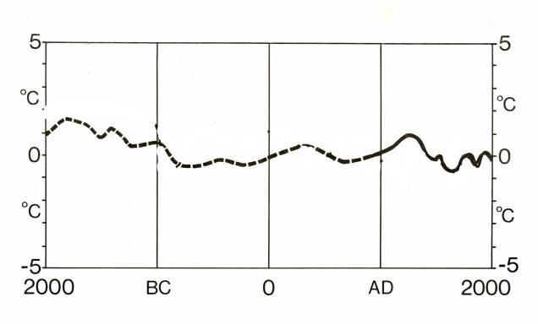
Figure 1. Whole year temperatures in Britain relative to 1980 (1980 = 0) (Lamb 1981 54)
The graph shows declining temperatures from near the start of the 2nd millennium BC to around 1000 BC followed by a sharper fall in temperatures to around 800 to 750 BC. At this point temperatures were the coldest they have been at any time during the last 4000 years (although temperatures have been at similarly low levels at other periods the cold spells have not lasted so long).
Clearly temperatures were not measured or recorded during the Iron Age so we have to study proxies for temperature change. One study looked at concentrations of sea salt and terrestrial dust in ice cores from Summit in Greenland (O’Brien et al 1995). There was an increase in these concentrations at various phases in the Holocene, including the period 1100 BC to 400 BC and the more recent historically attested Little Ice Age. The increase is believed to have been caused by an expansion of the North Polar vortex or an intensification of the meridional air flow and the results imply that, in northern latitudes, the period 1100 – 400 BC was the coldest since the Younger Dryas event (11,000 BP).
Another study looked at sediments from sea bed cores on opposite sides of the Atlantic (Bond et al 1997). Ice that enters the Atlantic around Greenland and Iceland brings with it certain traces of rocks. In cold periods this ice forms rafts across the surface and when it melts it deposits the traces on the ocean floor. The two sites told the same story; there were a series of Atlantic-wide cold events occurring at intervals of approximately 1400 years, one of which happened around 800 BC. Additional evidence from the same cores came from a study of the plankton. At the same time as the sediments appeared in the cores, cold water plankton species became more common, and warm water species less common. Another study also looked at plankton levels in marine sediments from the northern Icelandic shelf but used tephra layers from the eruptions of Hekla to date the sediments (Eiriksson et al 2000). They date one of the cooling events to 1000 BC.
A number of papers have emphasised the extent of the climate change event. Bond et al (2001) looked at ocean cores from three Atlantic sites and concluded that there was a cycle of cold spells about every 1500 years. They believed that these cycles were caused by fluctuations in solar output, amplified by the atmosphere’s dynamic response to changes in stratospheric ozone and temperatures. They also concluded that the magnitude of the change meant that the changes could not have been confined to the North Atlantic. Other studies, looking at glacial advances in Sweden (Denton and Karlan 1973) and archaeological sites in the Netherlands (van Geel et al 1996) confirm that the climate was getting colder and wetter all across northern Europe. The Swedish glacial advances were dated from 1000 BC to 300 BC with a peak at around 800 BC. The changes in the Netherlands showed that Terps (house platforms) had been built up gradually between 3350 to 2845 BP as the water table rose but were abandoned between 2760 and 2620 BP.
In summary there is ample evidence to show that there was a significant climate deterioration at the start of the first millennium BC. There is some irony in the fact that the prime suspect for the downturn, reduced solar irradiance, also affected the ¹⁴C in the atmosphere and this interfered with the radiocarbon calibration curve and made it difficult to accurately and precisely date events around this time. However, in broad terms, there is a wealth of evidence to support the view that, across north-west Europe, the climate started to deteriorate about 1200 BC. This deterioration accelerated after 1000 BC and was coldest and wettest from about 800 BC to 500 BC. Lamb (1981 55) believes that the fall in temperature would have shortened the growing season by about five weeks and there would have also been an increase in stormy weather. There is evidence from sand dune formation across Britain that there were storms around 2800 BP and during the period 3400 to 2400 BP, and this evidence is summarised in Charman (2010). The dates will not apply to every location across north-west Europe and there will be exceptions, and some of the dates are arguable but there is little doubt that the magnitude of the changes had a significant lasting impact.

Chapter 3
The Late Bronze Age to Iron Age transition, Evidence for the Significant Changes
Metalwork
As mentioned in the introduction, bronze was more than just a metal for making tools, weapons and decorative items. Bronze was traded across Europe and in the late Bronze Age there seemed to be two trading routes into and out of Britain – a route between south-east Britain and central Europe via the Rhine, and a Mediterranean/Atlantic route (Cunliffe 2005 66). The style of metalwork in Britain was known as the Ewart style after a horde at Ewart Park that was typical of Bronze Age metalwork at this time. Cunliffe dates the style from 900 -700 BC but Needham (2007 40) thinks it was about 100 years before that (1000 – 800 BC) based upon a number of sites where the metalwork was associated with pottery sequences and the contexts had been radiocarbon dated. Hoards of this type of metalwork are relatively common and it seems that large quantities of bronze were taken out of circulation and deposited in the 9th century BC. Large parts of north-west Europe experienced the collapse or abandonment of the bronze-based exchange system at around the same time. Some bronze objects continued to be used after the period of deposition, together with increasing numbers of iron tools and weapons (O’Connor 2007 71). The style of metalwork manufactured at this time is known as the Llyn Fawr style and this is equivalent to the Hallstatt C metalwork in use on the continent from 800 – 625 BC (O’Connor 2007).
Treatment of the dead
A recent paper (Patterson et al 2022) looked at aDNA samples from 793 individuals from Britain in an attempt to gauge the extent of migration into Britain from the early Bronze Age to the pre-Roman Iron Age. They were able to obtain samples from all relevant periods with one exception. They did not have any samples from the period 850-650 BC. Partly this is because aDNA samples cannot be obtained from cremations which was the dominant rite at the time (Cunliffe 2004 543-544), but to have no inhumations at all is unusual. In the first part of the first millennium AD, after cremation, the ashes were buried, sometimes in an urn and sometimes without, in a cemetery often based upon an earlier barrow or sometimes a small individual barrow. However, the number of cremations found seems to be much lower than would be expected. This lack of visibility has led some to speculate on how people were disposing of their dead in the Earliest Iron Age. Cunliffe (2004 544) thinks that their cremated remains and their equipment could have been disposed of in rivers, explaining the distribution of swords and the apparent lack of burial grounds. This lack of evidence means that there is also no evidence of an Iron Age elite. Leaders of a community are usually treated differently in death but this did not seem to happen.

Agriculture
During the Late Bronze Age field systems had developed with linear boundaries and coaxial fields but in the Late Bronze Age to Earliest Iron Age transition longer linear earthworks (sometimes called ranch boundaries) became more common and hilltop enclosures, middens and scattered farmsteads became features in the landscape (Fowler 1983 188-192 and 60-78.
From the Late Bronze Age onwards the numbers of sheep, relative to the number of cattle increased, especially on the downland sites of Wessex (Hambleton 1999). However, the significance of cattle should not be downplayed. Although sheep outnumbered cattle in some regions such as the Wessex Downs, Iron Age cattle were much bigger than Iron Age sheep so provided more meat. Additionally, regions in the west of Britain still maintained cattle rather than sheep and even the Upper Thames Valley which is geographically close to Wessex did not show an increase in sheep relative to cattle (Hambleton 1999 88).
Petra Dark (2006) reviewed the evidence for climate change at the start of the Iron Age. Her objective was to find out if there was evidence for widespread land abandonment in the pollen record. She collated evidence from many different sources throughout Britain and, of 75 sites, 34 showed a consistent increase in agricultural activity or woodland clearance and 14 showed reduced agricultural activity or woodland regeneration. Evidence from the remaining sites showed no significant change. She speculates that there are two reasons why there could be an overall small increase in agricultural land: land that became unsuitable for crops was converted to pasture, or there had to be an in increase in area of agricultural land to counteract falling yields.
Ceramics
There was a significant change in the pottery being used. Before around 800 BC the pottery had been undecorated, but after 800 BC a variety of regional styles developed that were decorated, and these styles were generally without precedent (Cunliffe 2004 87-97). In the south-east of Britain the ultimate Deverel-Rimbury tradition pottery used during the 11th to 9th centuries BC (which usually only had a thin beaded decoration around the pot) was replaced by completely plain pottery of the 9th and 8th centuries but the early All Cannings Cross group, used during the late 9th and early 8th centuries BC had large zig zag patterns. This decorated style continued into the Middle Iron Age.
This change to ceramics is only relevant in the south and east of England. Wales and the north of Britain were aceramic in the Iron Age. Aceramic is not completely accurate as there some plain coarse-ware vessels used in the Iron Age but these must have been supplemented by vessels made from bronze or organic materials that have disappeared from the archaeological record (Cunliffe 2005 117-118).
Hillfort building
The most visible remains of the Iron Age are hillforts. There are over 4000 in Great Britain and Ireland (Lock and Ralston 2017). Some started as hilltop enclosures in the Bronze Age but the vast majority appear to have been constructed and used in the Iron Age. Most are on higher ground and the regional distribution of hillforts partly reflects the availability of suitable sites, although enclosures are sometimes found on low-lying flat land, and there are areas of the country where hillforts might be expected where there are none. Hillforts are found in all shapes and sizes from small enclosures (less than 1 ha) to very large enclosures such as Binden Hill on the Dorset coast with over 100 ha.
The function of hillforts is much debated (Cunliffe 2004 388-406, Brown 2009 224-237, Harding 2012 201-226). Their exterior banks, ditches and ramparts, together with elaborate gateways, make them look like defensive structures, although there is very little archaeological evidence for conflict around hillforts. The famous photograph of a defender of Maiden Castle with a Roman ballista bolt through his spine is clear evidence of conflict but this was about 600 years after Maiden Castle was built, so the function could well have changed during this time. The range of sizes of hillforts also probably indicates different functions. The smaller ones probably only enclosed living accommodation and a yard for animals to be kept, but the larger ones were probably enclosures for grazing animals (Cunliffe 2004 422-424). Balksbury is one of the larger early hilltop enclosures and was excavated between 1995 and 1997 (Ellis and Rawlings 2001). The interior was largely empty but there were a few structures, interpreted as fodder racks and temporary accommodation. The authors concluded that the enclosure was used for livestock management (culling, castrating, calving, lambing etc) at certain times of the year. There is not much evidence that early hillforts were inhabited. The large developed hillforts such as Danebury or Maiden Castle only became population centres in the Earlier or Middle Iron Age, after 550 BC for Danebury (Cunliffe and Poole 1991 231 ) and after 450 BC for Maiden Castle (Sharples 1991 83). Other hillforts close to Danebury did not develop in the same way and, as Danebury flourished, they fell out of use. This variation in use of hillforts is well illustrated by the Wessex Hillforts Project (Payne et al 2006) who conducted magnetometer surveys of 19 hillforts in central southern England. The hillforts studied had a range of sizes and complexity; the surveys revealed that there was a range of activity levels within the hillforts. Some had very few pits or hut circles but some showed numerous magnetic anomalies including pits and hut circles but the complexity of the interior did not always correlate with the complexity of the exterior. Like the Wessex Hillforts Project, the most intensive studies of hillforts have concentrated on central southern England where hillforts are usually found on the edge of downland, overlooking the vale down below. The downland habitat is unusual because it is dry, so conclusions drawn from this area may not be transferable to other hillfort locations. Other functions of hillforts have been proposed. To some (Harding 2012 17) they are central places serving or controlling a territory, but many are in close proximity to other hillforts and in those cases may mark the edge of territory. Recently it has been proposed that their location and morphology are designed to impose themselves on their landscape (Murray 2018) and their dominance is best seen from the route normally taken to approach the hillfort. There are many different theories and the lack of consensus probably means that not all hillforts had the same primary function and that primary function probably changed over time.
Ridgeway Hillforts
Barclay et al (2003 244) summarised the chronology of Iron Age hillforts along the Ridgeway in Figure 2. Uffington Castle, Segsbury Camp, Liddington Castle, Alfred’s Castle, Blewburton Hill and Hardwell Camp all start life around 850 – 775 BC, although some of the dates are not precise. Other hillforts that had origins in the Late Bronze Age appeared to have a palisade prior to ramparts being built. These were summarised by Brown (2009 31) and examples include Castell Odo, Hembury Castle and Eddisbury.
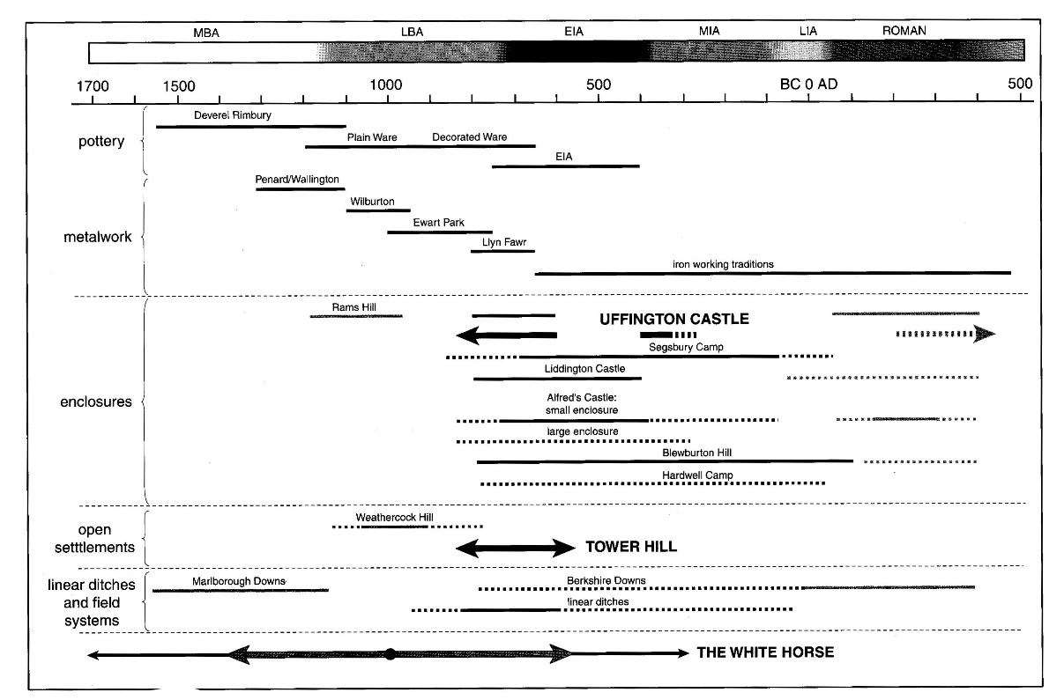
Figure 2. Dates of Ridgeway Hillforts (Barclay et al 2003 244)
Until recently, hillforts with proven origins in the Late Bronze Age were thought to be comparatively rare. The data from the hillforts database (Lock and Ralston 2017) show that, of the 1225 hillforts of England, only 36 have proven origins in the period 1200 to 800BC. Most hillforts were built after 800 BC. One feature of the earlier hillforts is their association with linear features known as ranch boundaries. Uffington Castle has one running about 2.5km to the south west towards Rams Hill and Tower Hill (Gosden and Lock 2003 127). A (very) recent publication by Campbell (2022) examines Late Bronze Age hilltop sites in the west (Wales and south-west England) and although she makes a distinction between these sites and full-blown hillforts it is possible that more hillforts had Late Bronze Age antecedents.

Pits
Pits from the Earliest Iron Age are usually shallow (Valdez-Tullett 2017) and unsuitable for grain storage (Thomas 1991 63). Large pits only become a significant feature after 600 BC and Valdez-Tullett says that before 600 BC four post structures are equally rare. This implies that smaller volumes of grain were being stored in the Earliest Iron Age than would be the case in later periods, and this applied to the lowland gravels of the Upper Thames Valley as well as the chalk uplands of Wiltshire.
After use, pits were deliberately filled and some appear to contain ritual deposits that could include complete or partial human remains, animal remains or unusual artefacts.

Chapter 4
The Impact of Climate Change on Iron Age Farmers
There is clear evidence that the climate got colder and wetter in the first quarter of the first millennium BC, getting colder from about 1000 BC then getting wetter from about 800-750 BC. The colder temperatures would have had a greater impact on more northerly latitudes because of the impact of the colder polar water on the ocean surface (Lamb 1981 55). The sharper thermal gradient between northern Scotland and southern Britain would have led to windier weather across Britain during colder periods. The increased precipitation would frequently fall as snow in the colder weather, so blizzards would have been a significant feature in Earliest Iron Age Britain. Additionally, the cooler temperatures would have shortened the growing season by about five weeks (Lamb 1981). Not all of Britain would have been affected equally. In the east of Britain there is evidence from the East Riding of Yorkshire and Lincolnshire (Lamb 1981 55) that the climate was relatively dry during the Iron Age suggesting that the winds were overwhelmingly coming from the west and depositing most of their rain on the western side of the country.
These changes would have had a significant impact on Iron Age farming. Increasing rainfall would have led to increased soil erosion and wetter valley bottoms. In winter the increased precipitation would have led to more snow and the combined effect of the changes would be to make arable farming less productive.
Evidence for Wetter Lowland Conditions
Lambrick and Robinson (2009 29-30) summarised the evidence for rising water levels in the Upper Thames Valley in the Late Bronze Age/Early Iron Age. In the Middle and Late Bronze Age the Upper Thames Valley was seasonally dry allowing soil formation. These soils were later covered by clay allowing the soils to be studied. At Port Meadow, Oxford the fills of Bronze Age ring ditches were not waterlogged but the fills of Iron Age ditches at the same depth contained waterlogged plant remains. At Yarnton a paleochannel was dry for most of the Bronze Age but by the Late Bronze Age there was sufficient water in the channel to preserve timbers. An oak stake from the structure was radiocarbon dated to 920-520 BC. At Oxford a low-lying area of the floodplain became drowned in the Late Bronze Age or early Iron Age (Robinson 2003 77). This rising water table continued into the Iron Age and a large shallow lake formed in the area that is now St Aldates and organic remains were radiocarbon dated to 760-50BC. Mingies Ditch also shows evidence of a rising water table between the Late Bronze Age and the Middle Iron Age.
An unusual feature of the flooding is that it is clean water flooding as evidenced by the molluscs found in the flooded channels. Lambrick (2009 31) believes that this was caused by tree clearance in order to create more grazing land, however tree clearance is usually believed to increase erosion so the flooding would be dirty water flooding. It is possible that the flooding was simply caused by increased rainfall and the change from arable to pastoral agriculture had already happened and this led to less erosion. Arable land left bare overwinter is more susceptible to erosion than grassland. In the Middle Iron Age the nature of the floodwater changed and began to carry a heavier sediment load and one explanation for this could be that by this time agriculture was changing back to arable. This suggests that the change from arable to pastoral agriculture at the end of the Bronze Age was driven by the decreasing temperatures between 1000 and 800 BC. When rainfall increased around 800-750 BC the land was predominantly pasture so there was not much sediment load in the floodwater. In the Middle Iron Age there was more arable agriculture and therefore more sediment in the floodwater.
Wetter valley bottoms would limit the agricultural activities that could be conducted. Arable farming would be more difficult and less productive, and animal grazing would have to be limited. Overgrazing with cattle would turn the land into a boggy morass, and this appeared to have happened at the Middle Iron Age site on Port Meadow in Oxford where the types of beetle found, and the types of vegetation indicated animal grazing and very wet conditions (Lambrick and Robinson 2009 46).
Agriculture on the Downs
On the downlands of southern Britain the downs are dry. There are no streams and no ponds. The evidence suggests that the downs were used for arable agriculture in the Bronze Age but at the start of the Iron Age there was no new development of field systems; instead ‘ranch boundaries’ become a feature of the landscape (Cunliffe 2004 420) indicating that, on the Downs, arable farming was replaced by grazing animals. Since the Downs are dry and cattle need to water to drink and sheep get all the water they need from the grass they eat, it is likely that sheep were grazed on the Downs. This is confirmed by the isotope studies of Schulting (2019). His research was designed to see if animals were moved between upland and lowland locations during their life. He looked at sheep, pig and cattle remains from two Ridgeway sites (Segsbury and Alfred’s Castle) and two nearby sites from the lowlands of the Vale (Watchfield and Marcham). Strontium isotope studies demonstrated that the sheep remains found at Segsbury and Alfred’s Castle spent all their lives up on the downs, and the sheep remains from Watchfield and Marcham came from sheep that had spent all their lives in the Vale. For sheep, there was no movement. The cattle remains found at the hillforts show that the cattle had spent most of their lives in the Vale and appear not to have spent much time on the higher ground before slaughter. Pigs found at the Ridgeway hillforts lived their lives on the downs before slaughter, and pigs found at the lowland sites lived their lives in the Vale before slaughter there. So, the only animal that shows any movement is the cow and they were probably only moved to the hillforts prior to being slaughtered for food.
From the Late Bronze Age onwards the numbers of sheep, relative to the number of cattle increased, especially on the downland sites of Wessex (Hambleton 1999). Iron Age sheep were a smaller breed than most modern sheep, probably similar to the Soay sheep, and their coat was quite hairy and would probably have been removed by plucking rather than shearing. Nevertheless, it could be spun and woven and spindle whorls and loom weights are common artefacts on Iron Age sites (Cunliffe 2004 487). Today we think of woollen items as knitted garments but woven woollen cloth would have had fewer gaps and, because it retained natural oils, would have been water resistant. Iron Age sheep supplied several different products and they have a beneficial impact on arable farming as the sheep can be grazed on arable stubble after the harvest and they then manure the land. The mortality pattern of sheep (age at death) can give an indication of the main purpose of the sheep flock. If lambs are killed young (just a month or two old) it is likely that the sheep are being used for milking. If they go to 18 months old that are probably being used primarily for meat. If they are several years old before being killed they are most likely to be being used for wool production. The best wool producers were castrated rams (wethers). Although Hambleton did not see much regional variation in age at death, Serjeantson (2007) looked at individual sites in the south of Britain and concluded that some sites specialised in certain aspects of the exploitation of sheep. At East Chisenbury (dated to the Earliest Iron Age) a large proportion of lambs were killed at around two to three months so the site was probably specialising in dairy products. Other sites specialised in meat production or wool production.
Like Iron Age sheep, Iron Age cattle were also smaller than their modern counterparts and the main products were meat, milk and hides.
Arable Agriculture
So, if the uplands were used for grazing sheep and the lowlands used for grazing a limited number of cattle where did the Iron Age farmers grow other crops? They would need to grow grain and pulses for human consumption and possibly other fodder crops for the animals. Some crops may have been suitable for both human consumption and fodder, for example, the ‘Celtic’ bean (Treasure and Church 2016). At Danebury they did manage to grow crops in damp locations and weeds found amongst the crops showed that crops were being grown on nearby flood plains (Cunliffe 2004 409). In some locations land slopes gently from lowland to upland and the sloping fields can be used for arable farming. In the Thames valley the upper gravel terraces are sufficiently far above the water table to grow crops. In some places there is an abrupt change between lowland and upland and the hillsides are too steep for arable agriculture. An example of this is the area around the Iron Age hillforts of Battlebury and Scratchbury (see Fig. 3) where terraces have been cut into the hillsides for arable farming. This is one of many examples where terraces and hillforts are close to each other so it is reasonable to assume that the terraces were cut in the wettest part of Iron Age when well drained arable land was not available.

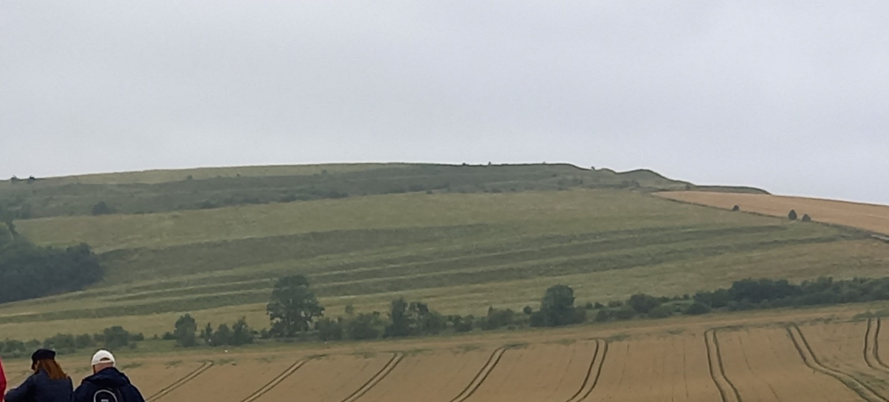
Figure 3. Terraces on the hillside near Battlesbury. Photo: Author
Other examples of terraces near Iron age hillforts are shown below in Figures 4 and 5. The images show terraces cut into soil on the lower slopes which has washed down from the upper slopes; this soil is deeper than that on the hill tops and not as clay-like as the soil in the valley bottoms therefore easily ploughed with an Iron Age ard (Reynolds 1981). The terraces would prevent further soil erosion.
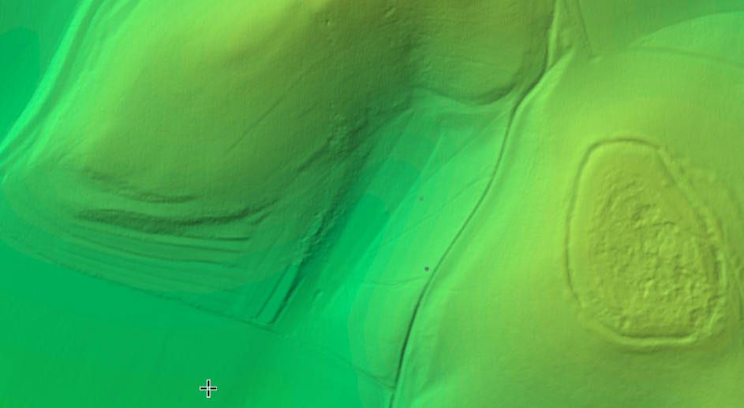
Figure 4. Terraces near Rybury Camp. LIDAR image from National Library of Scotland (2022)

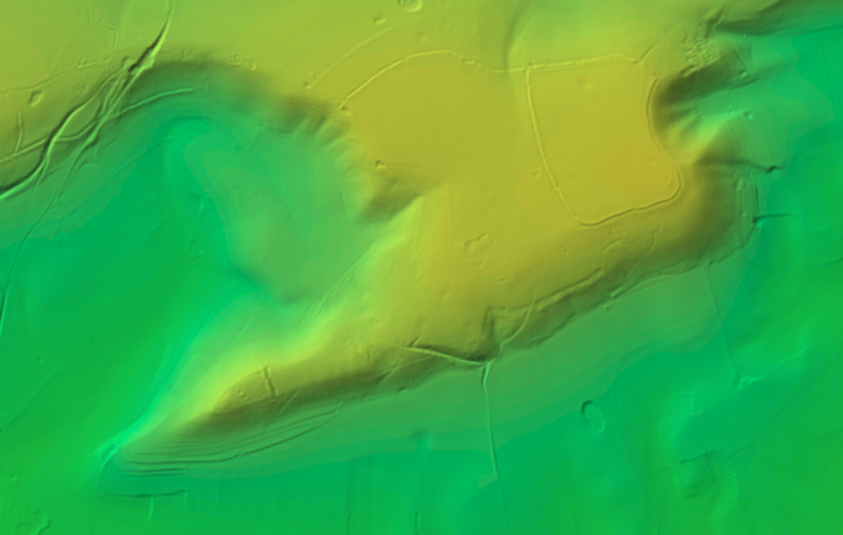
Figure 5. Terraces (bottom left) near Martinsell Hill and Giants Grave. LIDAR image from National Library of Scotland (2022)
Given the colder and wetter weather and the shorter growing season what arable crops did they grow? Charred grain samples from numerous sites show that emmer wheat was being grown in the Late Bronze Age, with an increasing amount of spelt in the Iron Age (Jones 1981 104-105). The presence of charred grain in the Iron Age has been contrasted with the lack of charred grain in the Neolithic. This difference has been used to argue that cereal crops were unimportant in the Neolithic (Thomas 1991 19-25 ) but more recent studies argue that grain was equally important (Jones and Rowley-Conwy 2006). One possible explanation is that charred grain is the result of a grain drying process that was misjudged. In the Neolithic the climate was much more forgiving than in the Iron Age and grain could be harvested in dry weather. If it rained, the farmer delayed his harvest until it was dry. In the Iron Age he did not have this luxury and he had to harvest when it was ripe as there may be no dry weather coming up. But before storage the grain needed to be dried artificially, either in an oven or by some other method, and was occasionally left too long. Unfortunately, there is no archaeological evidence for grain drying in the Iron Age and Reynolds (1979 74) has performed experiments at Butser to demonstrate that grain that has not been dried artificially could be successfully stored in pits. The pits need to completely sealed and kept at a low temperature but grain can be stored overwinter without spoiling and is able to germinate when planted.
Some crops became more widespread in the Iron Age. Spelt wheat and the celtic bean were known in the Neolithic but became more common in the Iron Age. Bread wheat was known in the Bronze Age and became more common in the Iron Age but rye, common oats and bristle oats seemed to make their first appearance in the Iron Age (Fowler 1983 163). Spelt comes to dominate the crop record (Applebaum 1954) and in part, this may be because it is suitable for autumn sowing. Autumn sowing gives the crop a head start in the spring so it is more successful when there is a shorter growing season. Confirmation that spelt was probably autumn sown came from Butser (Hillman 1981 146) where they found that autumn sown spelt had the same weeds associated with it as spelt in the archaeological record. Spring sown spelt had different weeds. The other reason that spelt became more popular maybe because it is better suited to heavier more acidic soils (Jones 1981 106). In the Late Bronze Age the Downs, with their lighter soils, had been used for arable cultivation but when these converted to pastoral agriculture, arable cultivation shifted to heavier clay soils of the lowlands.

The Increase in Dairying
The evidence for an increase in dairying comes partly from changing patterns of land use. By the Late Bronze Age field systems had developed, that suggested that the land was being used for arable farming but in the Iron Age new land divisions appeared that cut across old field boundaries and divided the land into much larger units. The landscape around Danebury, investigated by Cunliffe (2005 421-426) in the Danebury Environs project has examples of these, but similar divisions can be seen in Berkshire, Wiltshire, Hampshire and Dorset (Fowler 1983 189). However, this only demonstrates that the fields were being used for animals. It could be that animals were only being exploited for meat and other secondary products. Direct evidence for the use of dairy products comes from chemical analyses of residues on pottery (Copley et al 2003). Pottery from 14 sites across Britain was tested for traces of dairy products. Four of the sites were Iron Age hillforts and the analyses showed that dairying was an important activity on all four sites.
At the start of the Iron Age only around 10% of the adult population of Britain were able to process lactose, the sugar found in milk (Evershed et al 2022). The other 90% would have suffered from lactose intolerance to varying degrees so it is unlikely that the adult Iron Age population drank milk. It is likely that milk was converted to butter and cheese, both of which lose their lactose in the production process. Both these items can be stored for months in cool dark places.
Cows, sheep and goats could all have been sources of milk in the Iron Age and the results of the analysis of kill patterns of sheep at East Chisenbury have already been mentioned (Serjeantson 2007). Lambs were being killed fairly young suggesting that sheep were being milked after their lambs had been taken away. Sheep are not usually thought of as dairy animals, but they would be able to exploit the downs for pasture because they do not need water to drink; they get all the water they need from the food they eat. Sheep’s cheese is a novelty product today but it does demonstrate that sheep can be milked and their milk used to make dairy products. Goats are used more for their milk and in some areas goat’s milk and goat’s cheese are more popular than in Britain (eg France). The relative numbers of sheep to goats are difficult to estimate because their skeletal remains are very similar.
Overall, in the Earliest Iron Age, there was an increase in dairying when compared to arable crops, but this did have a positive impact on the crops that were grown. After crops had been harvested, animals would be turned out in the fields to graze the stubble and this would also manure the land, enriching it before the next growing season. There is evidence that this took place at Stanwick in Northamptonshire (Lodwick et al 2021). Charred cereal grains were analysed for nitrogen stable isotopes. Samples from the Late Bronze Age to Middle Iron Age had the most enriched ¹⁵N values indicating that they had been manured. Samples taken from later periods through to Roman times showed less manuring and this would be expected because, as the climate improved, there was a gradual change back to more arable and less pastoral farming so there was less manure available for more arable fields.
The winter weather from 800 BC onwards was wetter and colder so there would have been increased snowfall and the increasing number of storms would have produced blizzard-like conditions. This would have been especially problematic for the sheep grazing on the Downs. Snow accumulates where the wind slows down such as behind a hedge or a palisade. Sheep shelter from the wind in exactly those positions so they quickly get buried in snow (Figure 6).
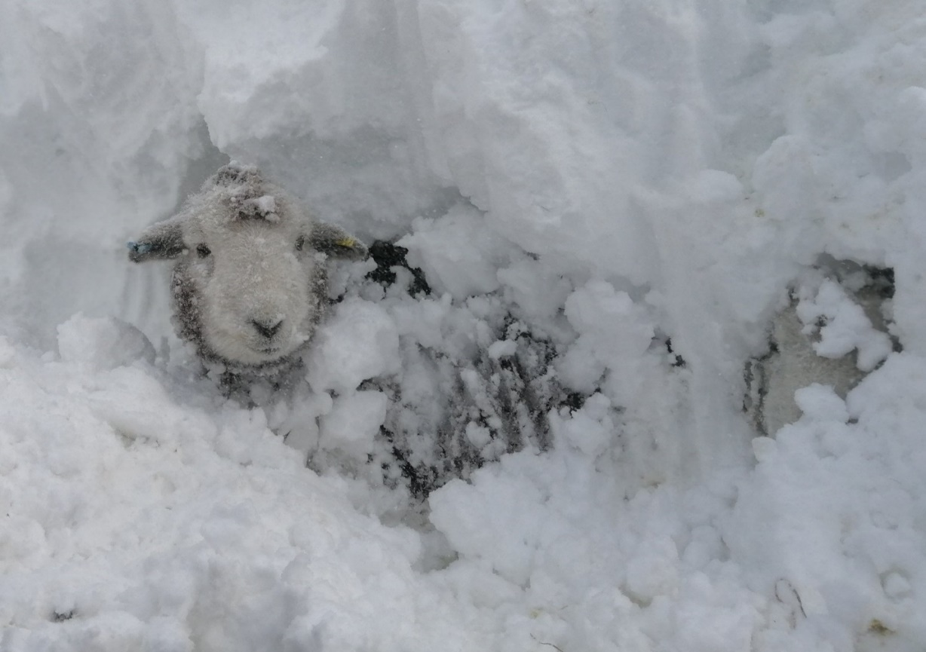
Figure 6. Sheep being dug out of snow. Photo: With permission of Herdwicks of Highfield Farm.
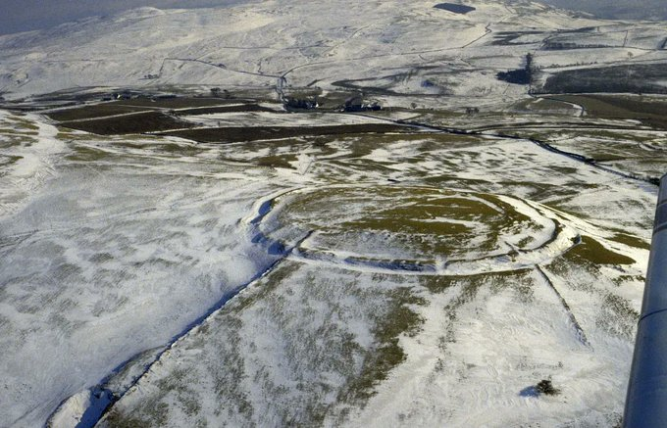
Figure 7. Caer Caradog hillfort in snow. Photo: © Clwyd-Powys Archaeological Trust

My hypothesis is that the primary function of the hillforts built after 800 BC was to protect sheep from the extreme weather conditions. Aerial photographs of hillforts taken after snowfall show snow accumulating in the ditches and the centre of the hillfort mainly clear of snow (Figure 7).
This answers the question why hillforts are in such windswept, inhospitable places. They are there so that hedges, palisades and ditches can trap the snow outside the hillfort and the wind can keep the interior clear of snow. Palisaded enclosures are known from various sites and double palisades are also known (Harding 2012 57). If their function was to slow down the wind so that snow is deposited, then the barrier need not be continuous. In fact, a non-continuous barrier works better because, with a continuous barrier the wind just blows straight over the top.
Storage of Food through the Winter
At hillforts there would have been a requirement to store fodder for sheep. This may have been the function of the pits mentioned earlier (Valdez-Tullett 2017), which were too shallow to be used for grain storage. It has been argued that large scale haymaking did not begin until the adoption of the iron sickle around 700 BC (Hejcmanová 2014) but there is little archaeological evidence either way. Nevertheless, it is known that the leaf vegetation of trees was collected and stored for winter fodder (Hejcmanová 2014). Some species of tree make better quality fodder than others and, in the UK, ash and elm were two readily available species that provide good quality fodder, and the important thing is that these trees produce new growth each year, whatever the weather.
For human consumption grain, pulses, meat and dairy products would need to be stored in suitable conditions. The storage facilities available were storage pits and four post structures. Both of these have been thought of as grain storage sites but in the Earliest Iron Age, when the climate was at its worst, there was a switch to pastoral rather than arable farming and less grain would be available to store; there was still a requirement to store seed corn but even this requirement would be reduced if there was a significant switch to autumn planting. As Valdez-Tullet (2017) pointed out the shallow pits of the Earliest Iron Age were unsuitable for storing grain so it is likely that they were used for the storage of other foodstuffs.
Dairy products such as butter and cheese can be stored for longer if they are salted but also benefit from cool, dark conditions and this may be one function of storage pits of the Earliest Iron Age. At 1m below ground level the bottom of the pit would be frost free all year and would also be cooler in summer (Worcester Bosch 2007), so the pits could be used to keep foodstuffs cool. Therefore, cheese made in the summer could be kept until the winter. Food stored for the winter would have been Iron Age farmers most precious possessions. An increase in dairying led to the storage of butter and cheese through the winter and these products began to be treated differently. Instead of being stored in everyday throwaway pots they were stored in new styles of decorated pottery. In central southern England the quantity of pots in circulation increased in the Iron Age (Needham 2007 55), perhaps reflecting the increased storage of dairy products.
Kinory (2011) looked at the distribution and use of salt in Britain in the Iron Age and highlighted the use of salt as a food preservative. Meat can be preserved by cutting the meat into thin strips, then soaking in brine for a short time, then drying the strips. It could also be preserved by rubbing dry salt directly into the meat, although this uses a large amount of salt. To dry the thin strips of meat they would need to be dried on a rack and Kinory (2011 245-246) suggests that the four post structures may have housed racks for drying meat.
Whilst fodder was stored at hillforts, food for human consumption may not have been. Many hillforts have little sign of human habitation and Iron Age communities often lived in small, unenclosed or ditched settlements dispersed throughout the landscape (Cunliffe 2005 237-305). Many have their own pits and four post structures which were probably used for storage.
There was a clear requirement to store fodder over the winter but food for human consumption would need to be stored for longer. The first requirement would be for this to last until the next harvest was due but there would also be a requirement for a buffer in the event of a bad harvest (Halstead and O’Shea 2009). In the Earliest Iron Age, they were not using grain for this buffer. Animals and animal products were their protection against a worsening climate and fodder was readily available and easily collected. Therefore, at a time of adverse climate change, a pastoral system of farming was a much safer than a mainly arable system.

Chapter 5
Examples of how specific hillforts interacted with the landscape
Hillforts of the Ridgeway
The hillforts of the Ridgeway are amongst the best studied in Britain. Segsbury Camp (Lock et al 2005) Uffington Castle (Miles et al 2003) and Alfred’s Castle (Gosden and Lock 2013) have been studied extensively and additionally, Barbury Castle and Liddington Castle have both had geophysical surveys (Payne et al 2006). Alfred’s castle is not typical as it is smaller than the others and in a unique upland position. The others are at the edge of upland and linked to the vale below.
My hypothesis is that hillforts were an essential part of the Iron Age agricultural system, but mainly concerned with the management of the sheep flocks that grazed on the Downs. In the same system there would be pasture for cattle, arable land for growing crops, and woodland. Uffington Castle is in the parish of Uffington which has, starting from the northern end, pasture for cattle with access to the River Ock for water, arable land just to the south of Uffington as evidenced by remnants of ridge and furrow, and grazing for sheep on the Downs. Unsurprisingly the adjacent parish of Kingston Lisle has access to exactly the same elements. Liddington Castle has a similar layout with respect to the parish of Liddington.
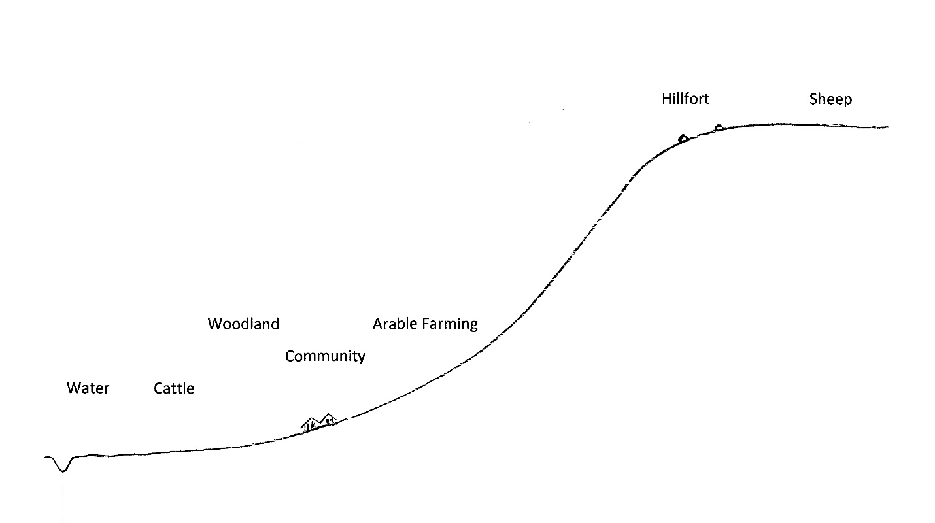
Figure 8. Layout of Ridgeway parishes. Diagram by Author.
In this system cattle have to graze on the lowland near the river as they need water to drink. But the river valleys were wet in the early Iron Age as demonstrated by Lambrick and Robinson in the Upper Thames Valley (2009 29,30) so overgrazing would have turned the grazing land into a quagmire. It was necessary to limit the grazing and it is possible that this was the driving force behind the creation of common land.
With common land, people who live in a certain place have rights to exploit the land. The usual right is the right to graze animals but other rights such as the right to take wood or the right to take turf are also known. The impact is that people that have rights are limited in the number of animals they can graze and everybody who does not have rights is excluded.
Figures 9 and 10 show the similarities between Liddington, Uffington, Kingston Lisle. All are long narrow parishes with the southern end of the parish on the downs. Liddington Castle, Uffington Castle and Ram’s Hill are all located on the edge of the downs, and at the northern end of the parishes on the lowland there is evidence of common land, even on modern maps. In Liddington parish, the roundabout on the A419 going north is known as Common Head roundabout and the area was known as Common Head before the construction of the roundabout. In Uffington parish the farm just north of Uffington village is known as Common Farm. In Kingston Lisle parish the farm to the north of Kingston Lisle is known as Kingston Common Farm. A map of the open fields of Uffington before enclosure also shows Woolstone Common to the north of Woolstone village (Parsons and Millikin 2014 35). These parishes are following the pattern noticed in Figure 8 with the place names indicating former commons. The commons in these four examples are all lowland commons. They are not the upland commons found mainly in the west of Britain where grazing animals wander over extensive areas of rough grazing on poor quality soils.
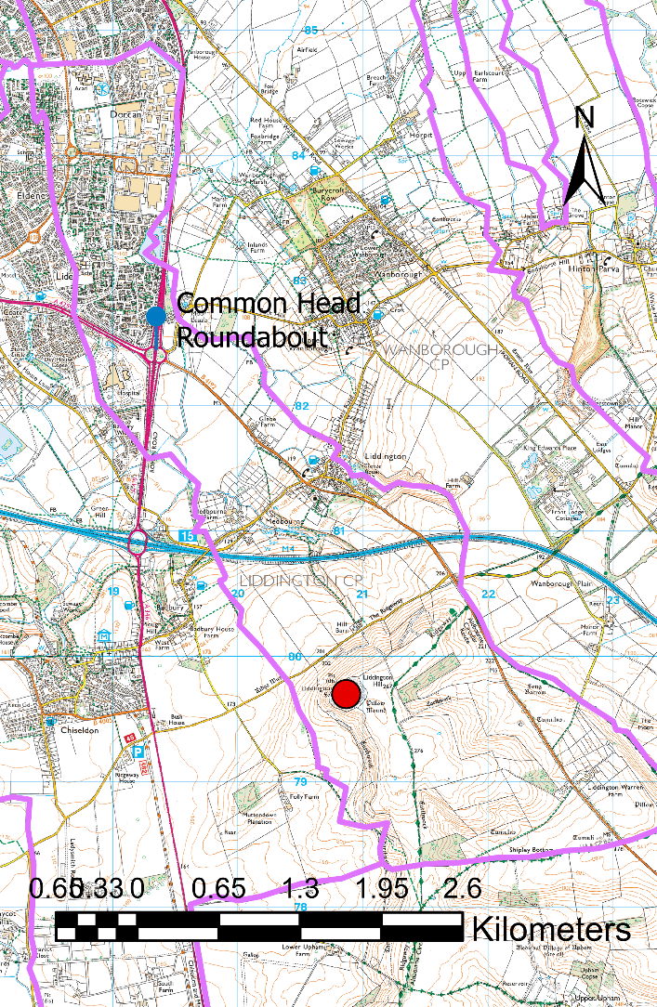
Figure 9. Liddington Castle. Created by author in ArcGIS using OS data from Edina Digimap. ©Ordnance survey. Key: Hillfort – red dot, common land - blue marker, parish boundaries - lilac line.
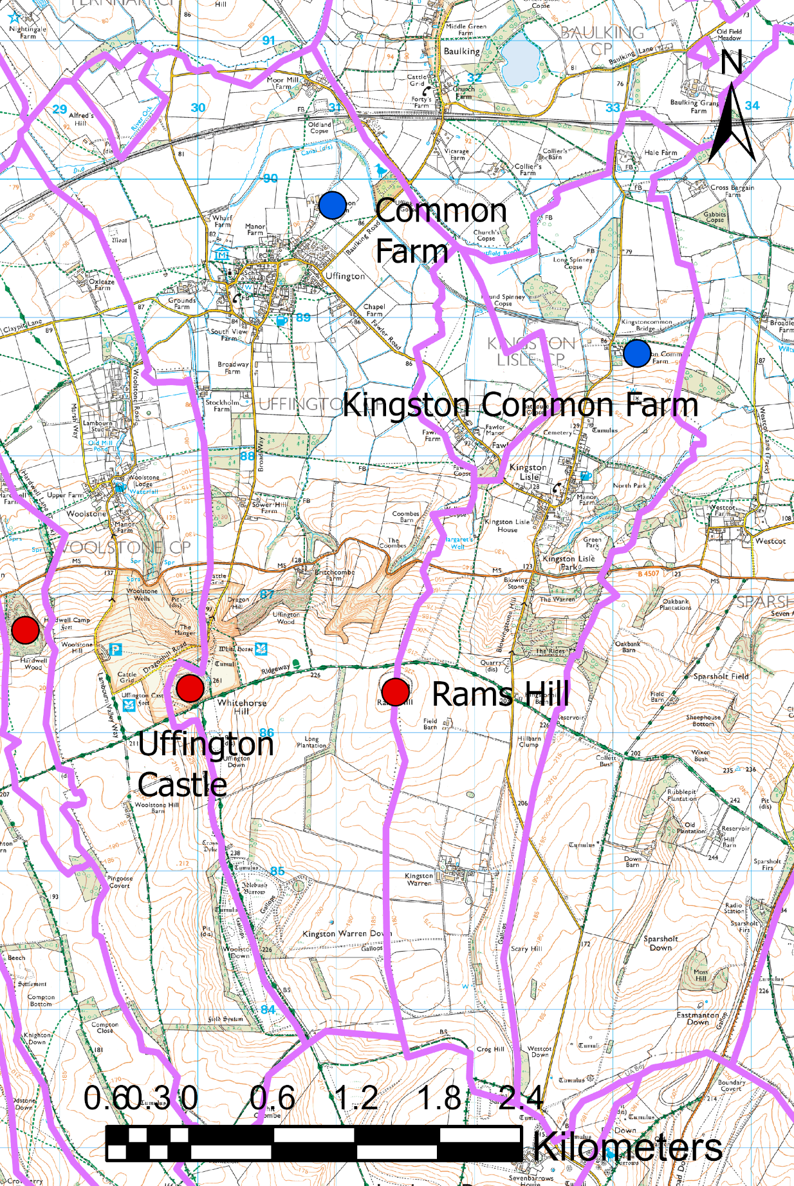
Figure 10. Uffington and Kingston Lisle Parishes. Created by author in ArcGIS using OS data from Edina Digimap. ©Ordnance survey. Key: Hillfort – red dot, common land - blue dot, parish boundaries - lilac line.
Uffington Parish boundary goes around Uffington Castle but this is a relatively recent change of 1778 when the land was being enclosed (Parsons and Millikin 2014 23). Prior to this the parish boundary had gone straight through the middle of the hillfort. Lord Craven wanted all of Uffington Castle but was only being allotted land in Uffington Parish, so he managed to get a change in the parish boundary incorporated into the Enclosure Act so he was able to get what he wanted. The parish boundaries shown in lilac are the boundaries from 1851 and there have been some changes since then, for example the small part of Baulking parish has been divided between Uffington and Kingston Lisle. Rams Hill is an Iron Age hillfort around a Bronze Age enclosure (Bradley and Ellison 1975) and that also has the parish boundary running through it. Hardwell Camp is another Iron Age hillfort to the west of Uffington Castle and is in a part of Uffington parish isolated from the main part.
There are other areas that demonstrate a relationship between Iron Age hillforts and common land. Purton parish and an area north of Newbury will be investigated in more detail.
Purton Parish
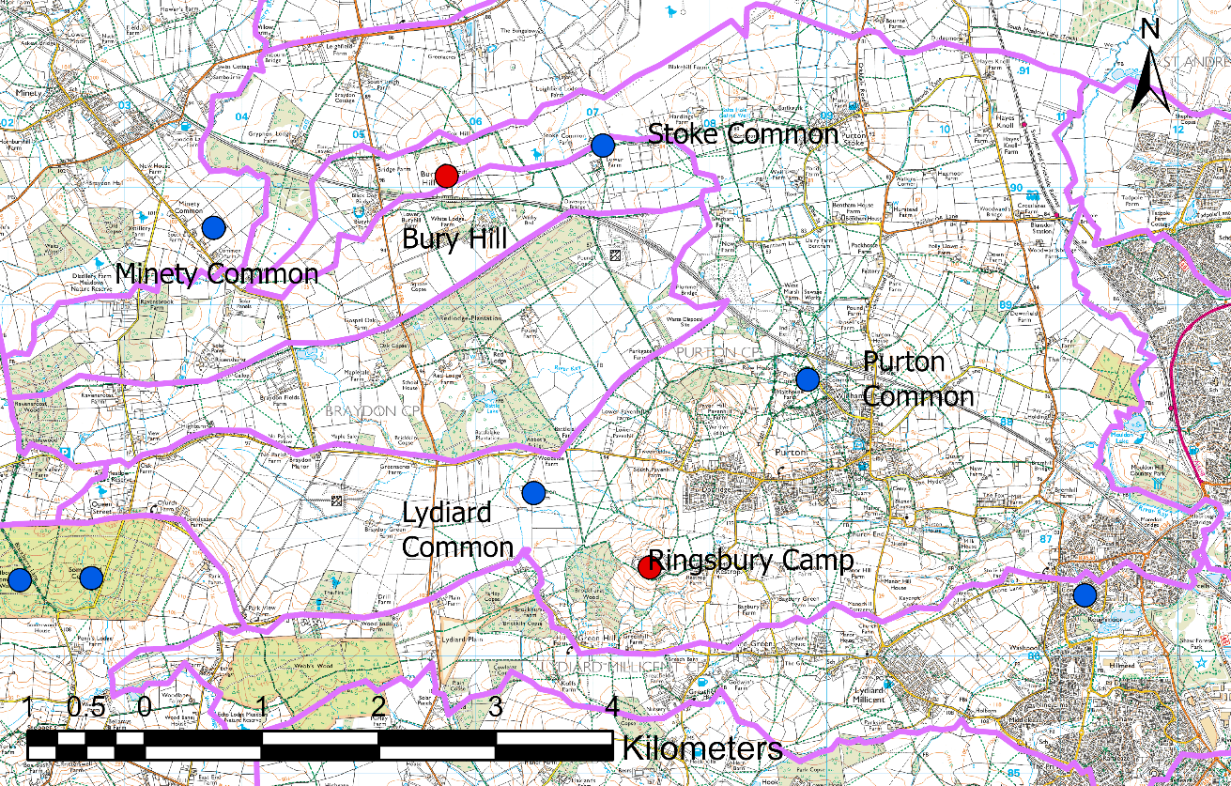
Figure 11. Purton Parish. Created by author in ArcGIS using OS data from Edina Digimap. ©Ordnance survey. Key: Hillfort – red dot, common land - blue dot, parish boundaries - lilac line.

Purton is a large parish to the west of Swindon and includes two Iron Age hillforts, Ringsbury Camp and Bury Hill. Ringsbury Camp is a well preserved, mostly univallate hillfort but although it has been ploughed internally in the past, the ditches and ramparts are mostly intact. Bury Hill is mostly ploughed out but can be seen from LIDAR images and Victorian Ordnance Survey maps. Within the parish there are three areas of common land, Lydiard Common, Purton Common and Stoke Common.

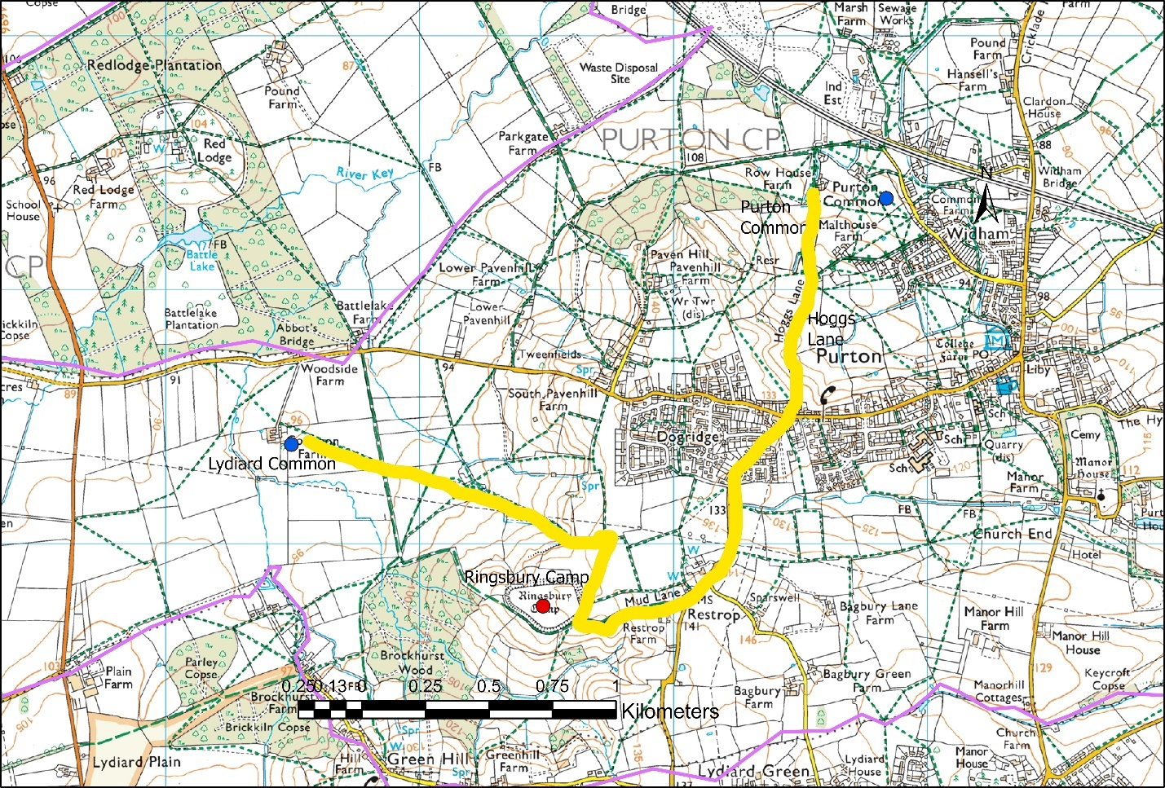
Figure 12. Ringsbury Camp, access to common land. Created by author in ArcGIS using OS data from Edina Digimap. ©Ordnance survey. Key: Hillfort – red dot, common land - blue dot, parish boundaries - lilac line.
Ringsbury Camp has access by footpaths to Lydiard Common, and to Purton Common by Mud Lane, a minor road and Hogg’s Lane. A hogg is a one-year old sheep, so the placename evidence suggests that at one stage in their life, sheep were being moved from Purton Common to Ringsbury Camp (or vice versa). Bury Hill is connected to Stoke Common by Stoke Common Lane.

Newbury Hillforts
There are other instances of unusual arrangements between hillforts, common land and parish boundaries. Just north-west of Newbury there are three Iron Age hillforts: Oareborough Hill, Bussock Camp and Borough Hill.

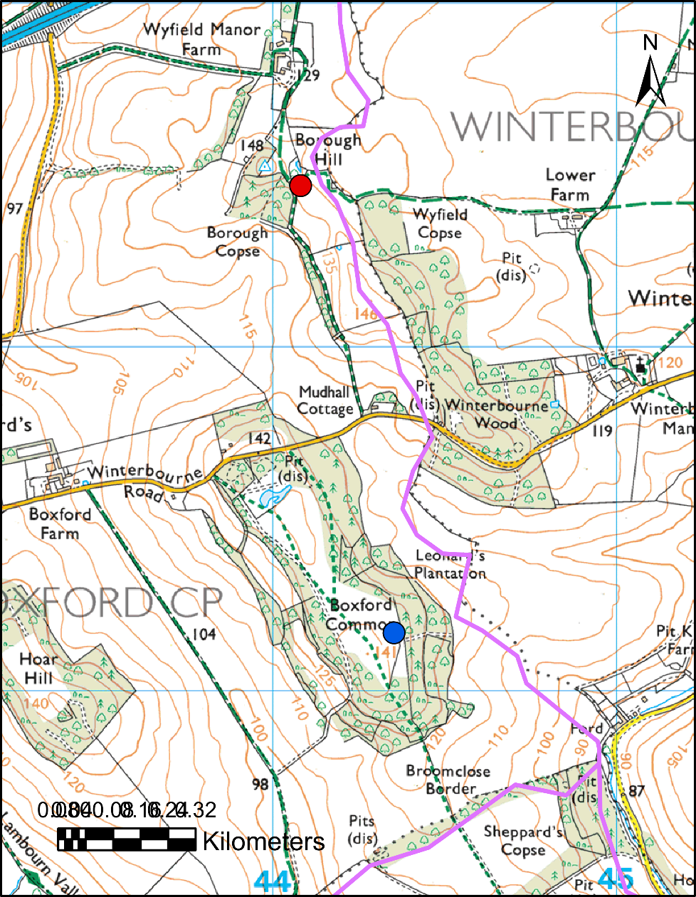
Figure 13. Borough Hill and Boxford Common, linked by footpath and linear feature. Created by author in ArcGIS using OS data from Edina Digimap. ©Ordnance survey. Key: Hillfort – red dot, common land - blue dot, parish boundaries - lilac line.

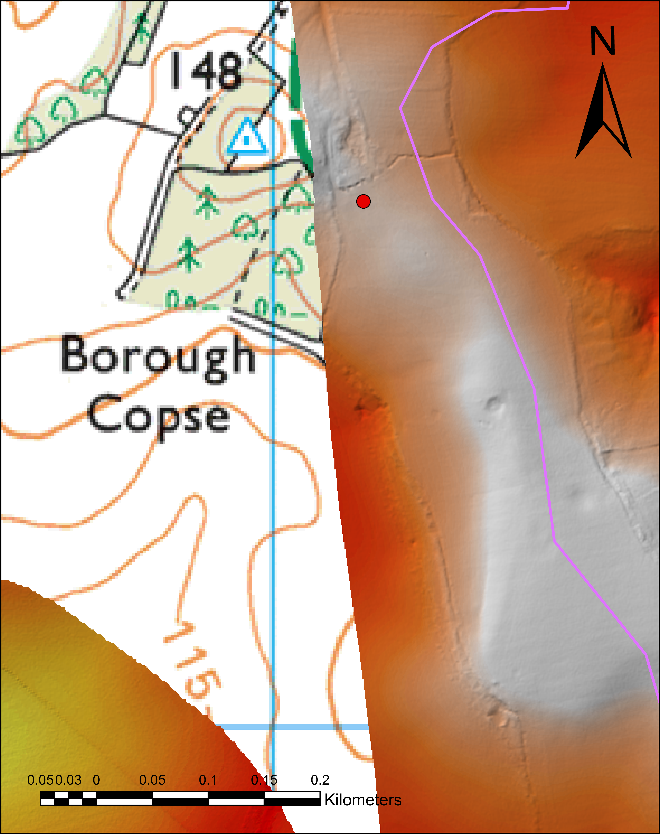
Figure 14. Linear feature on LIDAR. Created by author in ArcGIS using OS data from Edina Digimap and Environment Agency. ©Ordnance survey. Key: Hillfort – red dot, parish boundaries - lilac line.
The linear feature south of Borough Hill is not just a hedge, it is a long, narrow earthwork bounded by a low bank either side. It is not readily viewed on printed output but can be seen on the LIDAR image when magnified on screen. Unfortunately, there is a ‘hole’ in the LIDAR data so it is not possible to view Borough Hill itself. Borough Hill and Boxford Common are in the same parish (Boxford).

.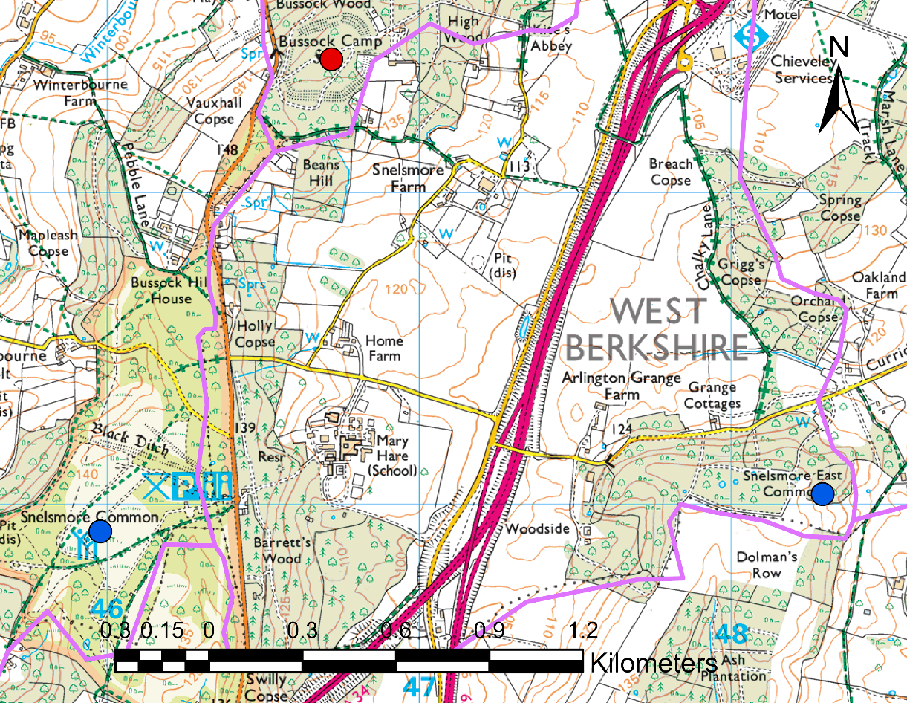
Figure 15. Bussock Camp, Snelsmore Common and Snelsmore East Common. Created by author in ArcGIS using OS data from Edina Digimap. ©Ordnance survey. Key: Hillfort – red dot, common land - blue dot, parish boundaries - lilac line.

Bussock Camp is in an unusual position, in Chieveley parish but touching the parishes which contain Snelsmore Common and Snelsmore East Common. Bussock Camp is linked to Snelsmore Common by the same unusual surface geology, sand and pebbles.
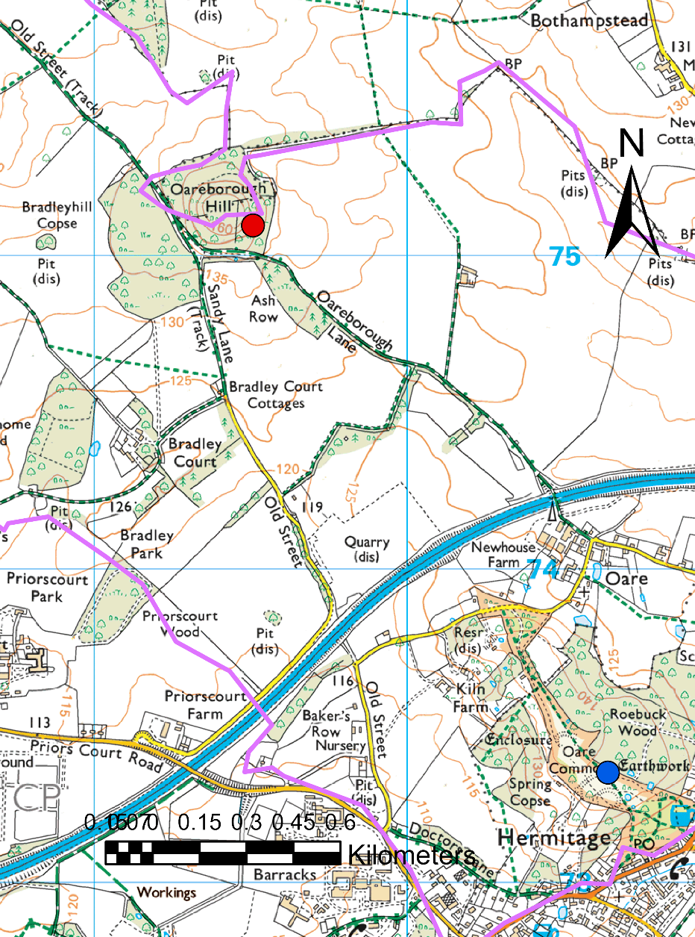
Figure 16. Oareborough Hill and Oareborough Common. Created by author in ArcGIS using OS data from Edina Digimap. ©Ordnance survey. Key: Hillfort – red dot, common land - blue dot, parish boundaries - lilac line.

Oarborough Hill has the parish boundary running straight across the middle of it. It is connected to Oare Common, about 2.5km to the south-east by either Oareborough Lane or Old Street. It is connected to Beedon Common, to the north-west by Old Street (not illustrated). There is a linear feature running alongside Oareborough Lane from the hillfort but no LIDAR data is available for this area, and because it is wooded it is difficult to get a good photograph.
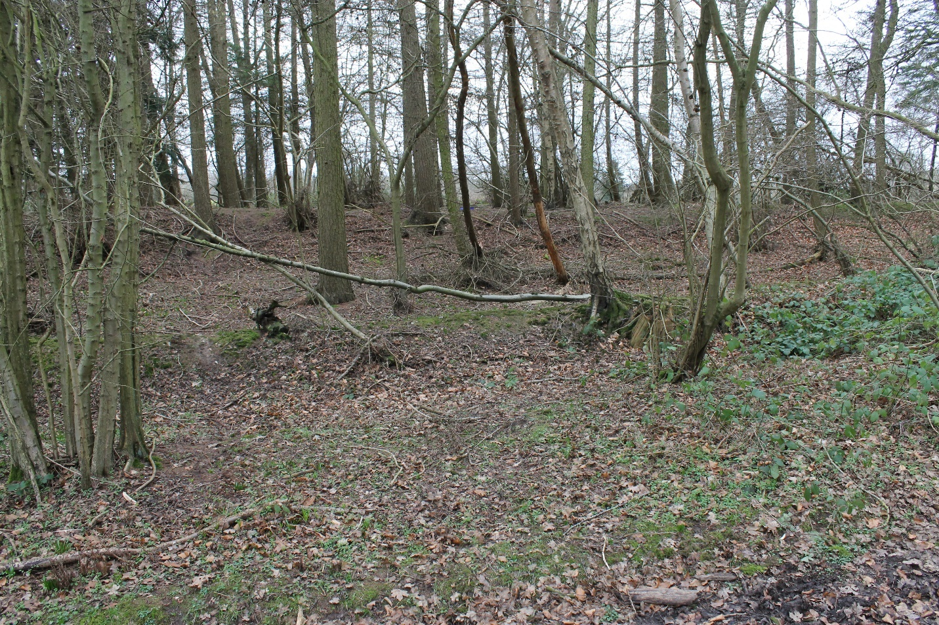
Figure 17. Linear feature running parallel to Oareborough Lane. Photo: Author.
These examples indicate that there may be a relationship between hillforts, commons and parishes. To determine if this is statistically significant a study area bounded by the OS explorer maps 169,170,158 and 159 was chosen. This is roughly the area bounded by Swindon, Oxford and Newbury. This area was selected because it includes a significant number of hillforts and common land and several different habitats including some downland and lower lying ground. Some of the hillforts were familiar to the author but many had not been studied beforehand, ensuring that this was a random sample, not selected to fit in with preconceptions. The Atlas of Hillforts (Lock and Ralston 2017) reveals 33 hillforts in the study area and two more have been added from Cotton (1962) giving a total sample of 35 hillforts. The commons in the same area were located from place name evidence on the maps with additional information added from historical Ordnance survey maps available online and from Cassini historical maps. In the location map below hillforts are marked as red dots and commons as blue dots. The outlines are parish boundaries of 1851.

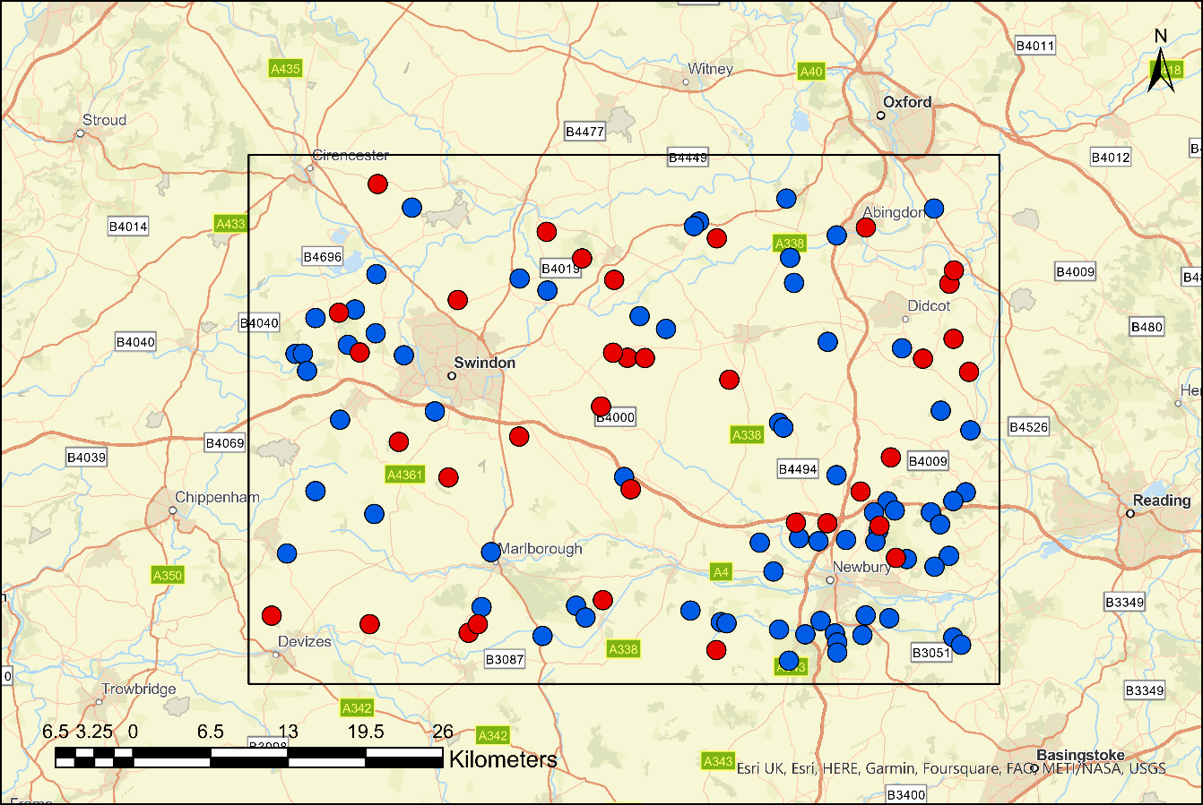
Figure 18. The study area and surroundings. Created by author in ArcGIS. Key: Hillfort – red dot, common land - blue dot.
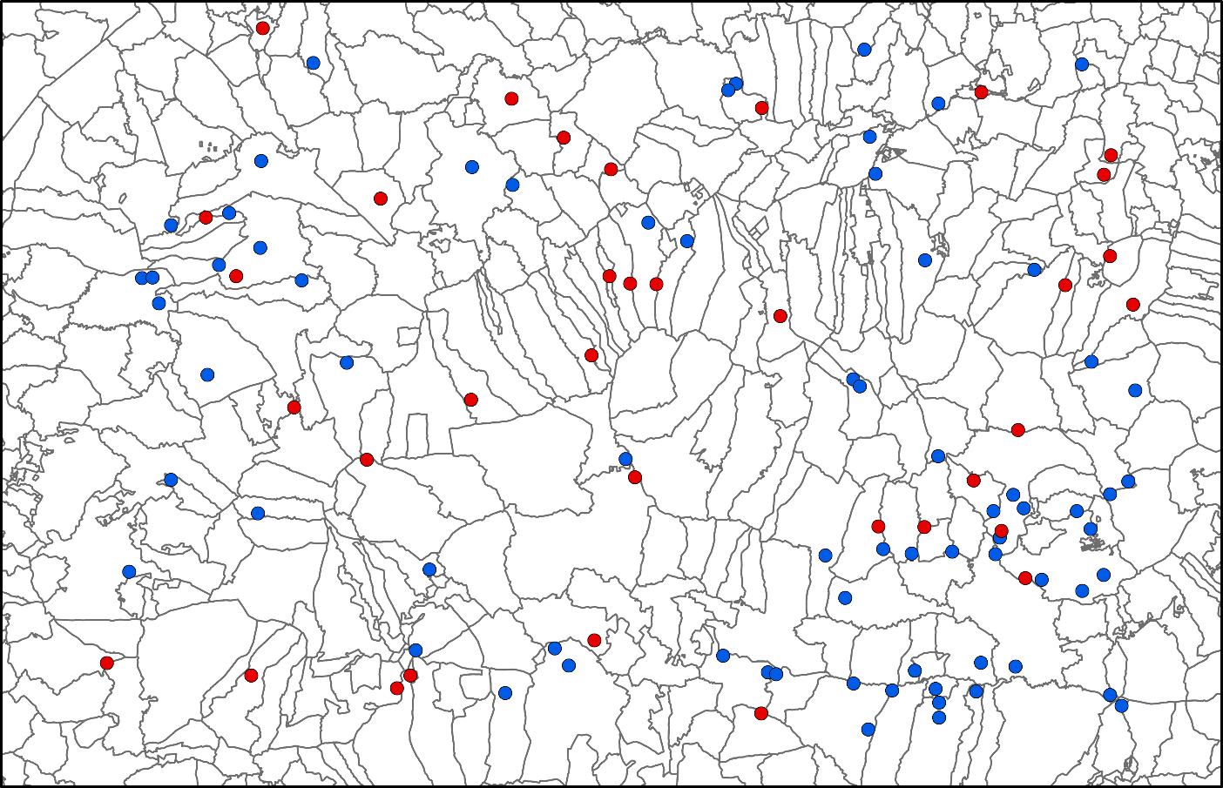
Figure 19. Hillforts, Commons and Parishes in the Study Area. Created by author in ArcGIS. Key: Hillfort – red dot, common land - blue dot.
Without the clutter of background mapping there are a few features to note. There are two clusters of commons in the south-east corner. Some are around Newbury and some are along the valley of the River Enborne (the southernmost cluster of blue dots). This would fit with the hypothesis that commons were introduced to limit grazing of cattle in wet lowland areas, but strangely the Kennet valley, just a few kilometres to the north of the Enborne has no common land. The lack of hillforts near the Enborne Valley commons suggests that these commons do not have an Iron Age origin.
The NEAR function in GIS was used to determine the distances from hillforts to the nearest common land (See Fig). To find out the distances that would be found if the distribution of common land was random and not connected to hillforts the distance accumulation tool was used to determine the distance from all cells in the study area to common land. The data were split into 1km bands and a histogram produced for each data set.

Figure 20. Distance of hillforts to nearest common land.
The results show that the nearest common to a hillfort is rarely more than 6km away but if commons were not associated with hillforts there would be more at higher distances. Certainly, there are some areas where common land is not associated with hillforts, and the obvious example of this is the common land in the Enborne Valley where there are 15 commons and only one nearby hillfort.
So how can an Iron Age feature (hillfort), an Anglo-Saxon feature (parish boundary) and an undated arrangement for looking after land be related?

Chapter 6
Discussion
Parish boundaries, which may have been formed in the 7th and 8th centuries (Blair 2005 153), usually follow landscape features that were visible in Anglo-Saxon Britain. Anglo-Saxons did not have maps but used verbal instructions that described routes or boundaries (Howe 2008) so therefore used features that were easily described and recognised. These are often watercourses but they also follow man made features such as Roman roads and there is an example of this in the study area. The A419 follows the line of the Roman road from Cirencester to Wanborough and near Swindon the parish boundaries follow the line of the road. The parish boundaries used in my analysis were the 1851 parish boundaries so not subject to late Victorian or modern alterations. Iron Age hillforts were striking, visible features of the landscape so it is not surprising that they were used as part of a parish boundary, either going straight through the middle of it or around it. For this to happen the hillfort need not be a functioning unit at the time, it just needed to be visible.
Parishes are often long and narrow running parallel to each other. They seem to be arranged like strip fields but on a larger scale. Whereas strip fields seem to be designed to distribute good and bad land equally between the strip owners, the parishes seem to be designed to spread out agricultural resources evenly. The obvious example, already discussed, is the parishes that border the Vale of the Whitehorse and the Lambourn Downs. The parishes of Bishopstone, Ashbury, Compton Beauchamp, Woolstone, Uffington, Kingston Lisle, Sparsholt, West Challow all follow the pattern in Fig 8, with downland in the south, sometimes including a hillfort, then a steep scarp slope leading down into the vale, with arable land and the settlement on the land that slopes a bit more gently, eventually leading to the bottom of the valley where there is access to a river or stream and common land. The examples from Purton parish and the Newbury area show routes between the hillfort and common land so does this mean that common land is an Iron Age feature?
Several authors have hinted that common land could have originated in prehistory and Herring suggested that Bronze Age pastures on Bodmin Moor were subject to collective controls (Herring 2008). Earlier work by Andrew Fleming (1988 45) had said that the stone rows of Bodmin Moor could mark a transitional zone leading to upland commons. Together these two authors were suggesting that the basic land use patterns were in place by the early years of the second millennium BC and that this landscape included land that was grazed collectively.
Oosthuizen (2013) listed the characteristics of the management system (Common property regime or CPrR) for common land:
- The rights to common pool resources are legal rights over property, enforceable by sanctions and the boundaries are known
- The rights over resources represent a structured ownership arrangement in which management rules are developed, the group size is known and enforced, incentives exist to follow accepted institutional arrangements and sanctions work to ensure compliance
- All right holders will participate in decision making, there will be regular meetings, decision making will be based upon consensus and changes require the consent of all rights holders
- The customs are recorded in oral traditions and minor amendments can be made each year
- Everybody can see that the rules are being adhered to
- Resources are distributed equally
There are many examples of prehistoric and Romano-British field systems remaining intact through the Roman period and into late antiquity in Britain. Romano-British fields at Chalton (Hants), Mucking and Havering (Essex) Bow Brickhill (Bucks) Sutton Courtenay (Berks and Yarnton (Oxon) continued to be used into the seventh century. There are exceptions but this continuity of usage seems to have been the norm (Oosthuizen 2019 106). In many places, grazing land was in continuous use from the Iron Age until the 18th century; the Cheviots, Exmoor, Dartmoor, the Somerset Levels, East Anglian Fens, parts of the Chalk Downs are all examples of grazing under possible shared property rights that survived for centuries.
Often grazing land in the prehistoric or Roman periods had the same physical characteristics as common land in medieval times. One of these characteristics was common access to common land and at Wetwang Slack each household had access to the same lane that accessed the common. It is possible that the grazing land was divided up into individual areas but there is usually no sign of internal divisions and this is the case on Exmoor, Dartmoor and the Wiltshire Downs. Survival of collectively exploited commons through the Roman period is suggested by the survival of their Brittonic names into the medieval period. Penge, Barnwood, Maisemore, Coit Maur (Selwood), Letocetum (a wood near Lichfield) all survived. Oosthuizen believed that, taken together, the evidence strongly suggests that common land could have originated in prehistoric times and survived, through the Roman period into medieval times and beyond. She argued that this continuity was evidence for a continuity of population in early medieval times. If there had been wholesale replacement of the local population by Anglo-Saxon newcomers then common land managed by a Common Property Regime, with its rules and oral traditions would not have survived.
There is a mechanism by which common land could have been introduced in the Iron Age. Exceptionally high levels of rainfall would have caused valley bottoms to become very wet and common land could have been introduced to limit grazing and prevent the grazing land becoming a quagmire. However, there are other, later periods when there were high levels of rainfall. Lamb (1981 55-63) says that the evidence is for a warming climate between the Late Iron Age to the end of Roman Britain, followed by a temperature downturn with wet periods at around 600 AD and 850 AD, so the conditions then would have been similar to those during the Earliest Iron Age if not so long lasting. The conditions that led to the building of hillforts as a safe place for sheep to shelter from snowstorms were repeated in the early Medieval period and this could be the driver for the ‘refortification’ of hillforts. Many hillforts seem to have been repaired at this time; one well known example is South Cadbury (Alcock 1972) which was put forward as evidence for Arthurian resistance to the invading Anglo-Saxons. Similarly common land could have been introduced at this time to limit grazing in waterlogged lowlands. There are two possibilities to explain the link between Iron Age hillforts and common land:
Common land was introduced in the Iron Age in response to climate change and each community had access to common land and upland with use of a hillfort shared with other communities. When parishes were laid out they followed existing land divisions that dated back to the Iron Age.
OR
When the climate deteriorated again in the period 600 to 850 AD hillforts were reused for their original purpose, keeping sheep safe from winter storms. Grazing land was protected by making it common land and when parishes were laid out they were laid out so that each community had access to the different elements of the landscape, including upland and lowland grazing.
The problem with both these arguments is that if common land was created as a result of environmental pressure, why did they continue to function when the environmental pressures were removed? If common land was created in the Iron Age why did it continue to function throughout the Roman period when the climate was warmer and drier and presumably there was widespread disruption of land ownership? It could be that, once the process for managing common land has been established, the benefits of managing lands collectively were readily apparent, and as the climate got warmer and drier the commoners did not want a return to a free- for-all where everybody grazed as much stock as they could in a limited area.

Chapter 7
Dorset
So far, this study has concentrated on central southern Britain, partly because this is the most studied area of hillforts in Britain and there is more archaeological evidence for this area than any other. However, hillforts are a widespread phenomenon with over 4000 in Britain and Ireland and over 1200 in England, so there many areas of Britain that offer suitable comparison sites.
One area famous for its hillforts is Dorset. The 37 hillforts within the county include the large multivallate hillforts of Maiden Castle, Eggardon, Hambledon Hill and Badbury Rings, and the extremely large enclosure of Bindon Hill. The topography of Dorset is different to that of the Downs in central southern England. Whereas the Downs tend to have Chalk plateaux and flat lowland, Dorset is more hilly with v-shaped valleys in between the hills. In Dorset the ground is fairly well watered with the spring line higher up the hillside than in central southern England.
Of the 37 hillforts, 13 have commons within 3km, although the search for commons has not been as extensive as it was for the study area between Swindon, Oxford and Newbury. Nevertheless, there appear to be fewer commons in Dorset, and this could be because of the topography. In Dorset there is more well-watered sloping land that is also well drained, so grazing animals do not turn the land into a boggy morass as much as they would on the flat valley bottoms of central southern Britain. With less need to limit grazing there is less requirement to create common land.
One type of hillfort seen in Dorset is the lowland hillfort near a river. These occur at Dudsbury Camp, Spettisbury Rings, and Sturminster Newton Castle and they are reasonably well preserved, and rather than being related to animal grazing may have a function connected with river transport. There are two possible equivalent sites in the main study area, at Burroway and Dyke Hills. Burroway is mostly destroyed but Dyke Hills seems to have been a trading settlement of some sort.
Parish boundaries appear to have a stronger relationship with hillforts than in the main study area. There, my conclusion was that when parish boundaries were created, they would have used hillforts as part of the boundary because they were very visible features in the landscape and need not have been functioning at the time. In Dorset, the relationship between parish boundaries and hillforts is more intimate and 17 of the 37 hillforts are touched by a parish boundary. One particular example stands out – Dungeon Hill hillfort (see Figure 21).
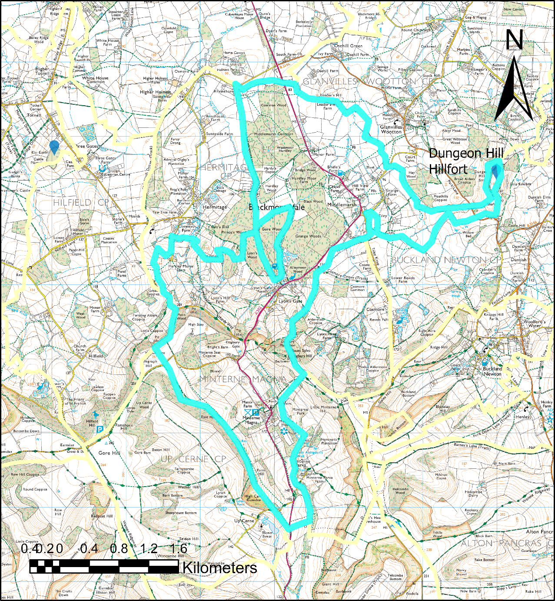
Figure 21. Dungeon Hill Hillfort, parish boundary and common land. Created by author in ArcGIS using OS data from Edina Digimap. ©Ordnance survey. Key: Boundary of Minterne Magna – blue line.

Dungeon Hill is almost surrounded by the parish boundary and is only connected to the rest of the parish by a narrow strip of land. In the northern part of the parish there are two parcels of common land: Common Wood and Middlemarsh Common. In the southern part is the village of Minterne Magna. The parish is very irregular and seems to have been designed so that Minterne Magna has access to a hillfort and common land.

Chapter 8
Summary and Conclusions
The research questions asked at the start of this dissertation were:
  - What is the evidence for climate change in the Late Bronze Age/Iron Age period?
  - What impact would climate change have had on the Earliest Iron Age farmers?
  - What did the Earliest Iron Age farmers do to ameliorate the impact of the deteriorating climate?
The evidence for climate change was presented in Chapter 2. There is evidence that the climate deteriorated at the start of the first millennium BC, getting colder from about 1000 to 800 BC and wetter after 800 BC. According to Robinson (1984):
“The first millennium BC is also regarded as a period when the climate became colder and wetter than previously, with perhaps a greater climatic change than any which had occurred since the warming of the climate at the end of the last glaciation.”
After the Iron Age there have been other cold wet periods but none have been quite so cold, quite so wet or so long lasting. In other words, at the start of the Iron Age it was colder and wetter than at any other time in the last 11,000 years, and although most writers acknowledge the climate downturn, they rarely acknowledge the severity.
By acknowledging the severity of the downturn, it is possible to answer the second research question: What impact did the climate downturn have on Iron Age farmers? According to Lamb (1981) the growing season would have been reduced by 5 weeks and there was an increase in stormy weather. This made the growing of arable crops more precarious and there would have been a period of falling yields. Low lying land got wetter so it would have been increasingly difficult to graze animals in the flat valley bottoms.
So, what did Iron Age farmers do to ameliorate the impact of the deteriorating climate? In central southern England one of the responses was to change how downland was used, from arable to pastoral. Crop yields would have fallen with deteriorating climate so the response was to rely less on crops and switch to dairying. Cows cannot survive on downland because of the lack of water, so sheep (which get all the moisture they need from the food they eat) were the animal best suited to that environment. Cows were still kept but on the lower lying ground which easily became boggy. It became necessary to limit lowland grazing. Some crops were still grown and there was a switch to different crops such as spelt and celtic beans which were better able to cope with the climate. The choice of crops suggests that arable land moved to heavier clay soils.
It is proposed that the primary function of hillforts was to protect sheep in the blizzards that would undoubtedly follow on from cold windy conditions with high precipitation, and also proposed that, in the Earliest and Earlier Iron Ages, the main functions of pits were to store fodder for keeping grazing animals alive in the winter, and store dairy products and meat for human consumption. There would have been a need to store some grain but this was not a major requirement.
One consequence that is explored in some detail is how far Iron Age farmers went to limit grazing on pasture. Was this the origin of common land? Several examples are given of hillforts that appear to have a relationship with nearby common land. Additionally, the NEAR function in ArcGIS is used to determine if the distance from hillforts to common land is as close as it would be if the relationship between hillforts and common land was random. The conclusion was that hillforts are closer to common land than would be expected if there was no link. This does not necessarily mean that the common land near Iron Age hillforts is an Iron Age feature. It could just have been pasture land in the Iron Age and the grazing animals brought to the hillfort for specific tasks such as collecting wool from sheep, lambing, sorting the flock into the sheep of different owners and similar tasks with cattle.
So, is common land an Iron Age feature or not? This dissertation has strengthened the case for it being so but the killer blow has not yet been landed.
This does raise the question of the nature of Iron Age Society. Was it a society where people would work communally for the common good? In the earliest phases of the Iron Age there is very little evidence for how they disposed of the dead and there is no sign of an elite being given any different treatment, so perhaps it was some sort of Marxist utopia where people were able to work together to agree how the common pasture land should be grazed. Perhaps they were also able to work together to construct a hillfort.
One of the drawbacks of this research is that the evidence is almost exclusively from central southern England, either the chalk downlands or the Thames Valley, so care needs to be taken if extrapolating these results to other areas. In a small attempt to compensate the county of Dorset was examined for similarities. The topography is different with less lowland common land but there was one interesting feature. When the parish boundaries were created an irregular boundary was drawn around Dungeon Hill and this was attached to common land. This implies that Dungeon Hill was performing an agrarian function when the parish boundaries were drawn up, and that function also required grazing land and grazing animals. At the very least this is evidence of continuity in the agrarian regime and the areas being used for grazing in the Iron Age were similar to those being used in the Medieval period when parish boundaries were being decided. Even today most hillforts are surrounded by grazing land, the only change in the last 2,800 years being the laying of blue plastic water pipe so that cows can be grazed in areas where before there was no water supply.
Future research
The climate of Britain didn’t start improving significantly until about 400 BC, but large storage pits and four post structures, both thought to be grain storage containers, were commonplace after 600 BC. It seems highly unlikely that there would be vast grain surpluses in the period between 600 and 400 BC so alternative functions for pits and four post structures need to be considered. Some alternatives have already been mentioned – storage for fodder or places for hanging meat to dry. Salt was probably used as a preservative in Iron Age Britain but a cheaper alternative was readily available thanks to the climate downturn – ice. Snow accumulates in the ditches of hillforts and in the Earliest and Early Iron Ages there would have been a plentiful supply. This could have been compacted to make ice and the ice could have been packed around meat or dairy produce in pits for longer term preservation. Unfortunately, there is no archaeological evidence that this ever happened and it is difficult to envisage potential archaeological traces. However, there are some historical parallels. Examples are known from Mesopotamia in 1780 BC, China in the 7th century BC and Alexander the Great in 300 BC (James and Thorpe 1994).
The presence of charred grain in some storage pits has led archaeologists to believe that storage of grain was their primary function. Using that same logic, it could be said that animal remains at the bottom of the pit demonstrated that the pits were used for the storage of animals for human consumption, and since agriculture had changed from mainly arable to mainly pastoral this would seem to be a more likely scenario.
One of the other big puzzles of the Earliest and Early Iron Ages is how they treated their dead. There are very few human remains found from this period and Cunliffe speculated that cremated remains could have been scattered in rivers, with their belongings, explaining the distribution of swords near rivers. Another example of ‘missing dead people’ came from the battlefield of Waterloo. Around 25,000 soldiers died at Waterloo but their remains are rarely found. One possible explanation for this is that the bodies were dug up and their bones ground up to make fertiliser (Pollard 2022) and this is an alternative explanation for the missing bodies in the Iron Age. Because of the climate downturn, Iron Age farming was under intense pressure and needed best possible yields.
The two examples discussed so far, ice used as a preservative and the missing bodies, will probably never have sufficient evidence to confirm them because it is difficult to envisage what data would achieve that objective. There is one area of research that it may be possible to investigate further by landscape evidence and that is the refortification of hillforts in the early medieval period. There is a correlation between building hillforts and climate downturn. Hillforts started to be built at the start of the Iron Age when the climate got worse. Most had been built by the time the climate started to recover around 400 BC, then many hillforts fell out of use, although some developed into the large settlements such as Danebury or Maiden Castle. Throughout the Roman period there are sporadic finds at hillforts, but nothing to suggest widespread use. The climate started to deteriorate again in the early medieval period and this coincided with the period of hillfort refortification. The circumstantial evidence points to hillforts having a role to play when the climate got worse and a landscape study that associated refortified hillforts with the agrarian landscape would build upon this study. The study should also include parish boundaries to see if the pattern of use at Dungeon Hill in Dorset is repeated elsewhere.
Finally, this study has centred on evidence mainly from central southern England, which is unique because the Downs are generally dry. The solution to the problem of falling arable yields was to introduce sheep but other areas of the country would not necessarily have solved the problem in the same way. A short examination of the Dorset hillforts suggested there were some differences here but an in-depth investigation of other areas is required. To investigate the farming regime effectively there would need to be data on proportions of animals in the bone evidence and also evidence of different crops being used at different times. Dorset has a reasonable amount of data but hillforts the English/Welsh border could also be used as an alternative study area.
Community Engagement
On Wednesday 9th November I shall be giving a talk on Iron Age hillforts to the Royal Wootton Bassett Rotary Club and on Thursday 24th November I am talking to Purton Historical Society on “Ringsbury Camp in the Iron Age” with the emphasis on local hillforts, talking about their function.
Appendices
Appendix 1 - Hillforts in the Study Area
Site Name | Easting | Northing
Ranbury Ring, Gloucestershire | 409000 | 200900
Bury Hill, Oxfordshire | 423182 | 196878
Rybury Camp, Wiltshire | 408330 | 163965
Oliver's Castle, Wiltshire | 400102 | 164681
Ringsbury Camp, Wiltshire | 407489 | 186760
Bury Hill Camp, Purton, Wiltshire | 405755 | 190102
Giant's Grave, Wiltshire | 416635 | 163244
Martinsell Hill Camp, Wiltshire | 417401 | 163970
Castle Hill, Blunsdon St Andrew, Wiltshire | 415716 | 191176
Chisbury Camp, Wiltshire | 427893 | 165971
Membury Camp, Wiltshire | 430214 | 175285
Barbury Castle, Wiltshire | 414933 | 176285
Liddington Castle, Wiltshire | 420869 | 179704
Bincknoll Castle, Wiltshire | 410772 | 179270
Alfred's Castle, Oxfordshire | 427735 | 182235
Blewburton Hill, Oxfordshire | 454750 | 186250
Little Coxwell Camp, Oxfordshire | 428850 | 192850
Sinodun Hill Camp, Oxfordshire | 456950 | 192550
Cherbury Camp, Oxfordshire | 437450 | 196350
Badbury Camp, Oxfordshire | 426150 | 194650
Uffington Castle, Oxfordshire | 429945 | 186325
Hardwell Camp, Oxfordshire | 428755 | 186745
Segsbury Camp, Oxfordshire | 438500 | 184479
Silsbury Hill, Oxfordshire | 458600 | 185134
Cholsey Hill, Oxfordshire | 457300 | 187900
Rams Hill, Oxfordshire | 431430 | 186300
Dyke Hills, Oxfordshire | 457350 | 193650
Abingdon, The Vineyard, Oxfordshire | 449950 | 197250
Grimsbury Castle, West Berkshire | 451094 | 172216
Bussock Camp, West Berkshire | 446720 | 172433
Walbury Camp, West Berkshire | 437408 | 161800
Ramsbury, West Berkshire | 452469 | 169532
Perborough Castle, West Berkshire | 452052 | 177966
Oareborough Hill | 449415 | 175173
Borough Hill | 443974 | 172503

Appendix 2 - Commons in the Study Area
Common Land | Easting | Northing
Common Barn | 411875 | 198912
Common Hill | 408900 | 193324
Stoke Common Farm | 407089 | 190360
The Common, Minety | 403762 | 189656
Purton Common | 408839 | 188360
Common Farm, Lydiard | 406497 | 187391
Milbourne Common Wood | 402105 | 186646
Somerford Common | 402717 | 186666
Common Platt | 411206 | 186518
The Common, Callow Hill | 403069 | 185207
Common Farm, nr Wroughton | 413789 | 181819
Greenhill Common Farm | 405850 | 181120
Highway Common, nr Hilmarton | 403762 | 175126
Pusey Common Wood | 435962 | 197725
Ayre's Common Plantation | 435537 | 197369
Watchfield Common Wood | 423232 | 191948
Common Farm, Uffington | 430975 | 189812
Kingston Common Fm | 433177 | 188742
Appleton Upper Common | 443288 | 199672
Old Common, Nuneham Courtney | 455686 | 198839
Abingdon Common | 447506 | 196590
Common Barn, East Hannay | 443602 | 194702
Cow Common, East Hannay | 443926 | 192597
Aldfield Common | 446757 | 187653
Common Barn, Blewbury | 452984 | 187112
Common Wood, Goring | 458724 | 180224
Common Plantation | 442658 | 180858
Brightwalton Common | 443033 | 180467
Cow Common | 456238 | 181868
Common Barn Copse nr Membury | 429678 | 176313
Berwick Bassett Common | 408716 | 173213
Marlborough Common | 418508 | 170008
Quemerford Common farm | 401386 | 169888
Bedwyn Common | 425634 | 165505
Clench Common | 417713 | 165399
Stock Common | 426433 | 164523
Burbage Common | 422824 | 162967
Beedon Common | 447497 | 176471
Common Barn nr M4 nr Little Hungerford | 451771 | 174277
Ashampstead Common | 458336 | 175037
Burnthill Common | 457289 | 174302
Frilsham common | 455402 | 173337
Common Firs | 452374 | 173506
Oare Common | 450644 | 173350
New Common, nr Frisham | 456180 | 172329
The Common nr Grimsbury | 451009 | 171832
Snelsmore East Common | 448296 | 171033
Boxford Common | 444355 | 171168
Sole Common, nr Wickham | 441064 | 170807
Snelsmore Common | 445979 | 170913
Cold Ash common | 450755 | 170892
Chapel Row Common | 456924 | 169706
Bucklebury Common (west) | 453395 | 169429
Common Wood nr Stockcross | 442195 | 168388
Bucklebury Common (East) | 455716 | 168784
Little Common | 435235 | 165097
Inkpen Common | 437790 | 164140
Inkpen Great Common | 438266 | 164042
Wash Common | 446158 | 164229
Greenham Common | 449933 | 164697
Crookham Common | 451910 | 164467
Sydmonton Common | 449666 | 163048
Newtown Common | 447357 | 163191
Common Farm nr Washwater | 444869 | 163102
Hatt Common | 442675 | 163515
Burghclere Common | 447548 | 162422
Brimpton Common | 457293 | 162844
Baughurst Common | 457949 | 162230
Earlestone Common | 447548 | 161567
Mount Common | 443505 | 160892
Common Farm, Highworth | 420918 | 192971

Appendix 3 - Dorset Hillforts
Site Name | Northing | Easting
Hambledon Hill, Dorset | 384506 | 112716
Abbotsbury Castle, Dorset | 355591 | 86561
Badbury Rings, Dorset | 396414 | 102992
Banbury Hill Camp, Dorset | 378995 | 111929
Bindon Hill, Dorset | 383568 | 80077
Bulbury Camp, Dorset | 392895 | 94224
Buzbury Rings, Dorset | 391869 | 105909
The Castle, Cattistock, Dorset | 359416 | 100101
Chalbury, Dorset | 369463 | 83845
Chilcombe Hill, Dorset | 353011 | 91948
Coney's Castle, Dorset | 337163 | 97523
Dudsbury Camp, Dorset | 407702 | 97918
Dungeon Hill, Dorset | 368995 | 107412
Eggardon, Dorset | 354070 | 94720
Flower's Barrow, Dorset | 386366 | 80555
Hengistbury Head, Dorset | 417263 | 90784
Hod Hill, Dorset | 385670 | 110648
Lambert's Castle, Dorset | 337179 | 99076
Lewesdon, Dorset | 343711 | 101237
Maiden Castle, Winterborne St Martin, Dorset | 366867 | 88470
Mistleberry, Dorset | 399576 | 119480
Nettlecombe Tout, Dorset | 373619 | 103258
Penbury Knoll, Dorset | 403949 | 117098
Pilsdon Pen, Dorset | 341253 | 101308
Poundbury, Dorset | 368216 | 91141
Rowlsbury Camp, Dorset | 376748 | 105813
Shipton Hill, Dorset | 350757 | 92151
Spettisbury Rings, Dorset | 391479 | 101981
Sturminster Newton Castle, Dorset | 378434 | 113466
Weatherby Castle, Dorset | 380710 | 96240
Woodbury Hill Camp, Dorset | 385637 | 94784
Woolsbarrow, Dorset | 389311 | 92552
Caesar's Camp, Dorset | 393018 | 115602
Old Warren, Dorset | 358418 | 88518
Colebarrow, Dorset | 403500 | 105800
The Castle, Leigh, Dorset | 363035 | 107738
North Poorton, Dorset | 351150 | 98874

Bibliography
Alcock, L. (1972) Cadbury Camelot. Thames and Hudson, London
Applebaum, S. (1954) The Agriculture of the British Early Iron Age, as exemplified at Figheldean Down, Wiltshire. Proceedings of the Prehistoric Society 20 103 - 114
Barclay, A., Cromarty, A., Gosden, C., Lock, G., Miles, D., Palmer, S. and Robinson, M. (2003) The White Horse and its Landscape. In Miles et al (2003 243-268)
Blair, J. (2005) The Church in Anglo-Saxon Society. Oxford University Press, Oxford
Bond, G., Kromer, B., Beer, J., Muscheler, R., Evans, M., Sowers, W., Hoffmann,S., Lotti-Bond, R., Hajdas, I. and Bonani, G. (2001) Persistent Solar Influence on North Atlantic Climate During the Holocene. Science 294 2130-2136
Bond, G., Showers, W., Cheseby, M., Lotti, R., Almasi, P., deMenocal, P., Priore, P., Cullen, H., Hajdas, I. and Bonani, G. (1997) A Pervasive Millenial-Scale Cycle in North Atlantic Holocene and Glacial Climates. Science 278 1257-1266
Bradley, R. and Ellison, A. (1975) Rams Hill: a Bronze Age Defended Enclosure and its Landscape. BAR, Oxford
Brown, I., (2009) Beacons in the Landscape – The Hillforts of England and Wales. Oxbow Books, Oxford
Charman, D. (2010) Centennial Climate Variability in the British Isles During the mid-late Holocene. Quaternary Science Reviews 29 1539-1554
Copley, M., Berstan, R., Dudd, S., Docherty, G., Mukherjee, A., Straker, V., Payne, S. and Evershed, R. (2003) Direct Chemical Evidence for Widespread Dairying in Prehistoric Britain. Proceedings of the National Acadamy of Sciences of the United States of America 100:4 1524-1529
Cotton, M. (1962) Berkshire Hillforts. Berkshire Archaeological Journal, 60 30-52
Cunliffe, B. (1984) Danebury, An Iron Age Hillfort in Hampshire, Vol 1, The excavations 1969-1978:the site. CBA Research Report No 52. Council for British Archaeology, London
Cunliffe, B. (2005) Iron Age communities in Britain (4th Edition). Routledge, Abingdon
Cunliffe, B. and Miles, D. (eds) (1984) Aspects of the Iron Age in Central Southern Britain. Oxford University Committee for Archaeology, Oxford
Cunliffe, B. and Poole, C. (1991) Danebury, an Iron Age Hillfort in Hampshire. Vol 4 The Excavations 1979-1988:the site. Council for British Archaeology, London
Dark, P. (2006) Climate Deterioration and land use changes in the first millennium BC: Perspectives from the British palynological record. Journal of Archaeological Science 33(2006) 1381-1395
Denton, G. and Karlan, W. (1973) Holocene Climate Variations – Their Pattern and Possible Cause. Quaternary Research 3(2) 155-205
Dickinson, W. (1975) Recurrence Surfaces in Rusland Moss, Cumbria. Journal of Ecology 63(3) 913-935
Ellis, C. and Rawlings, M. (2001) Excavations at Balksbury Camp, Andover 1995-1997. Proceedings of the Hampshire Field Club Archaeological Society 56 21-94
Eiriksson, J., Knudson, K., Haflidason, H. and Heinemeier, J. (2000) Chronology of the late Holocene climatic events in the North Atlantic based on AMS ¹⁴C dates and tephra markers from the volcano Hekla, Iceland. Journal of Quaternary Science 15 573-580
Evershed, R. et al (2022) Dairying, diseases and the evolution of lactase persistence in Europe Nature (2022). https://doi.org/10.1038/s41586-022-05010-7 (Last accessed 29/07/22)
Fleming, A. (1988) The Dartmoor Reaves, Investigating Prehistoric Land Divisions. Batsford, London
Fowler, P. (1983) The Farming of Prehistoric Britain. Cambridge University Press, Cambridge
van Geel, B., Buurman, J. and Waterbok, H. (1996) Archaeological and paleoecological indications of an abrupt climate change in the Netherlands and evidence for climatological teleconnections around 2650 BP. Journal of Quaternary Science 451-460
Gosden, C. and Green, C. (2021) English Landscapes and Identities. Oxford University Press, Oxford
Gosden, C. and Lock, G. (2003) The Linear Ditch, the Ridgeway and the Enclosure. in Miles et al (2003)
Halstead, P. and O’Shea, J. (1989) Bad Year Economics. Cambridge University Press, Cambridge
Hambleton, E. (1999) Animal Husbandry Regimes in Iron Age Britain: A comparative study of faunal assemblages from British Iron Age sites. BAR, Oxford
Harding, D., (2012) Iron Age Hillforts in Britain and Beyond. Oxford University Press, Oxford
Haselgrove, C. and Pope, R. (eds) (2007) The Earlier Iron Age in Britain and the near Continent. Oxbow, Oxford
Hejcmanová, P., Stejskalová, M. and Hejcman, M (2014) Forage quality of leaf-fodder from the main broad-leaved woody species and its possible consequences for the Holocene development of forest vegetation in Central Europe. Vegetation History and Archaeobotany 23 5 607-613
Herring, P. (2008) Stepping onto the Commons: South-Western Stone Rows. in Rainbird (2008) 79-88
Hillman, G. (1981) Reconstructing Crop Husbandry Practices from Charred Remains of Crops. in Mercer (1981)
Howe, N. (2008) Writing the Map of Anglo-Saxon England. Yale University Press, New Haven and London
James, P. and Thorpe, N. (1994) Ancient Inventions. Michael O’Mara Books
Jones, M. (1981) The Development of Crop Husbandry. in Jones, M. and Dimbleby, G. (1981)
Jones, M. and Dimbleby, G. (1981) The Environment of Man: The Iron Age to the Anglo-Saxon Period. BAR, Oxford
Lamb, H. (1981) Climate from 1000 BC to 1000 AD. in Jones, M. and Dimbleby, G. (1981)
Lambrick, G. and Robinson, M. (2009) The Thames Through Time. The Archaeology of the Gravel Terraces of the Upper and Middle Thames. The Thames Valley in Late Prehistory:1500 BC – AD50. Oxford Archaeology, Oxford
Lock, G., Gosden, C. and Daly, P. (2005) Segsbury Camp, Excavations in 1996 and 1997 at an Iron Age Hillfort on the Oxfordshire Ridgeway. Oxford University School of Archaeology, Monograph 61, Oxford
Lock, G. and Ralston, I. (2017). Atlas of Hillforts of Britain and Ireland. [ONLINE] Available at: https://hillforts.arch.ox.ac.uk Last accessed 16/09/22
Lodwick, L., Campbell, G., Crosby, V. and Müldner, G. (2021) Isotopic Evidence for Changes in Cereal Production Strategies in Iron Age and Roman Britain. Environmental Archaeology 26:1, 13-28
Mercer, R. (1981) Farming Practice in British Prehistory. Edinburgh University Press, Edinburgh
Miles, D., Palmer, S., Lock, G., Gosden, C. and Cromarty, A. (2003) Uffington White Horse and its Landscape: Investigations at White Horse Hill, Uffington, 1989-95 and Tower Hill, Ashbury, 1993-4. Oxford Archaeology, Oxford
Murray, J. (2018) A GIS-based Analysis of Hillfort Location and Morphology. BAR, Oxford
Needham, S. (2007) 800 BC, The Great Divide. in Haselgrove, C. and Pope, R. (2007)
O’Brien, S., Mayewski, P., Meeker, L., Meese, D., Twickler, M. and Whitlow, S. (1995) Complexity of Holocene Climate as reconstructed from a Greenland Ice Core. Science 270 1962-1964
O’Connor, B. (2007) Llyn Fawr metalwork in Britain: a review. in Haselgrove and Pope (2007 64-79)
Oosthuizen, S. (2013) Tradition and Transformation in Anglo-Saxon England. Bloomsbury, London
Oosthuizen, S. (2019) The Emergence of the English. ARC Humanities Press, Leeds
Parsons, A. and Millikin, S. (2014) Landscape Reinvented, The Uffington Enclosure Award 1778. Uffington Museum Trust, Uffington
Patterson, N. et al (2022) Large-scale migration into Britain during the Middle to Late Bronze Age. Nature 601, 588-594
Payne, A., Corney, M. and Cunliffe, B. (2006) The Wessex Hillforts Project. English Heritage, London
Pollard, T. (2022) These spots of excavation tell: using early visitor accounts to map the missing graves of Waterloo. Journal of Conflict Archaeology 16 2 75-113
Rainbird, P. (2008) Monuments in the Landscape. Tempus, Stroud
Reynolds, P. (1981) Deadstock and Livestock. in Mercer (1981)
Robinson, M. (1984) Landscape and Environment of Central Southern Britain in the Iron Age. in Cunliffe and Miles (1984) 1-11
Schulting, R., le Roux, P., Yee Min Gan, Pouncett J., Hamilton, J., Snoeck, C., Ditchfield, P., Henderson, R., Lange, P., Lee-Thorpe, J., Gosden, C. and Lock, G. (2019) The Ups and Downs of Iron Age Animal Management on the Oxfordshire Ridgeway, South-Central England: A Multi-Isotope Approach. Journal of Archaeological Science 101, 199-212
Sharples, N. (1991) Maiden Castle. Batsford, London
Simmons, I. and Tooley, M. (1981) The Environment in British Prehistory. Duckworth, London
Tallis, J. (1964) Studies on Southern Pennine Peats, 1. The General Pollen Record. Journal of Ecology, 52 323-331
Thomas, J. (1991) Rethinking the Neolithic. Cambridge University Press, Cambridge
Treasure, E. and Church, M. (2016) Can’t Find a Pulse? Celtic Bean (Vicia faba L.) in British Prehistory. Environmental Archaeology 22:2 113-127
Turner, J (1965) A contribution to the history of forest clearance. Proceedings of the Royal Society of London B 161(984) 343-354
Turner (1981) The Iron Age. in Simmons, I. and Tooley, M. (1981)
Valdez-Tullett, A. (2017) Sheep in Wealth’s Clothing: Social Reproduction across the Bronze Age to Iron Age Transition in Wiltshire, Southern England. European Journal of Archaeology 20 (4) 663-681
Worcester-Bosch (2007) Ground Source Heat Pumps – How they work.

